|  |
| --- |
| Pine Springs Pottery |
| User Manual |
| Pine Springs Pottery App & Cellica |

|  |
| --- |
| Tara Strine, Teresa Tickle, Wes Parsons, and Amanda Thomas  5/1/2014 |

Contents

System Documentation 2

Background of Pine Springs Pottery 2

Division of Labor 2

Limitations 2

Project Development 2

Anticipated Information Flow and Cycles 3

Implementation Manual 4

Physical Machines 4

Recreating the System 4

Accounts and Roles 4

Using the Program 5

New Customer 5

Wish List 8

Order History 9

New Show 9

Entering a New Order 12

Viewing an Order 18

Adding an Expense 19

Editing the Catalog 20

Browsing Customers/Orders/Shows/Expenses 22

Searching 23

Generate Reports 25

Installation 28

Making Address Labels from Access (Avery 5160 – Full sheets) 30

Guests for a Show 30

All Customers 31

Hosts 32

Cellica (Desktop) 33

Check Status of Syncing 33

Troubleshooting 33

Re-installing Cellica Desktop 35

Downloading 35

Adding Profiles 36

Importing Forms 37

Cellica (iPad) 41

Downloading the Cellica App for the iPad 47

# System Documentation

## Background of Pine Springs Pottery

Our employer was Marie Lewis the owner of Pine Springs Pottery. Marie’s problem was that since she started her business, she has kept all of her records in paper form. This created stacks of papers she would have to search through to find a specific order or customer. For example, if a customer called and asked about the pattern that her sister ordered, Marie would have to look through all the forms to find that customer’s order.

To solve this problem, we created a database for Marie and provided her with a Visual Studio’s program to access the database, as well as a Cellica program to view her database from her iPad. These programs allow Marie to access the database and enter information without actually dealing with the database herself.

## Division of Labor

Initially, the work for our project was divided into three part: Teresa creating the database, Tara, Wes, and Amanda sketching user interface designs, and Tara and Amanda working on Cellica. After that, the work was divided by what tasks each group member thought he or she could tackle. Amanda created the forms and profiles in Cellica and the search form in the Visual Studio program as well as implementing Google Maps from the expense form and implementing e-mail from the customer and show form. Amanda also came up with the idea of using Microsoft one drive to back up the database. Tara assisted with and tested Cellica and created the new show, new customer, wish list, and order history forms. Tara was also the person who contacted Marie when the group had questions or wanted to schedule a meeting. Teresa created the Access database and the new order, browse, catalog, and expense forms. Wes created the generate report form.

## Limitations

The first limitation of the Pine Springs Pottery programs is that we have no way of moving an item from the wish list to the order. Marie has to create an order with the item and then remove it from the wish list instead. The second limitation is that the reports are created at runtime because of our use of report viewer. The third limitation is that we do not have a way for Marie to make her mailing labels in the program. The forth limitation is it is difficult to add new entries to the database with Cellica.

## Project Development

Our project stared with our original meeting with Marie. We met with her to get an idea of what kind of system we needed. After meeting with Marie and hearing what she needed, we discussed what kinds of systems would be needed. We agreed on Microsoft C#, Access 2007, and Cellica to meet her needs. The first goal was to come up with the GUI. The GUI was developed on Saturday, March 4, 2014 by Amanda, Tara, and Wes. The GUI consists of a main menu that leads to other forms that fulfill each of Marie requirements. The group’s design kept true to the original design mostly throughout the whole project. Next, Marie took us to her workshop in order to view a demonstration of her business processes. This helped us think of how to take Marie’s current process and transform them into a digital system.

Armed with knowledge of how Marie conducted her business and suggestions from the interim report, we began to design the system. First, we needed to make sure that Cellica was a system that could meet Marie needs. Amanda and Tara spent the most time working with Cellica. In the time period of March 7th to March 14th, we did not want to continue work on the project until we were sure that Cellica worked well. We determined that it could allow Marie to view her data. We kept have issues with Cellica all throughout the project. Cellica was worked on until the end of April.

After spring break, we got right back to work, ensuring that each interface had the functionality it would need. Work was split up between group members; Tara was tasked with new show, new customer, wish list, and order history. Amanda was tasked with the search form. Teresa worked on new order, the catalog, browse/listings, and add expense. Wes worked on the reports that Marie would print off while working.

We spent that last week of March and all of April working on the functionality of the C# application. The C# application is meant to protect the database. It took longer than expected due to starting the programing later inexperience with databases. We were able to implement Marie’s requested features with only a few of the features unimplemented. We got a working version from Marie to test on the first of May and will fix any problems she might have.

At the end of April, we started our first round of training. Teresa and Amanda were the only two who were able to attend. The first installation was good, since it allowed us to get some more feedback from Marie. This allowed for some more debugging. A second installation is planned for the sixth of May.

## Anticipated Information Flow and Cycles

Since Marie did not have software to store her data before this, we were able to start from scratch on this project; however, Marie had kept a lot of data that showed us what the program would need to be able to do. This project may need work done in the future, but it should work well until Marie is ready to expand again.

The Access Database file, located in the program’s installed folder, should be backed-up once a week, or at least after data entry from each show. The file is backed-up by copying it into Marie’s SkyDrive. It can be restored by copying it from her SkyDrive and replacing the current copy in the program’s installed location.

The main software can be restored by the installation CD provided to Marie. The installation CD will contain the PC software, database, and the Cellica forms. To restore the software, Marie can place the CD into her computer and follow the installation wizard. The Cellica forms, database file, and PC software will all be located where the program is installed. The database file will need to be restored to the latest backed up version. If Cellica is reinstalled, a profile will need to be recreated to the database file and the forms loaded.

# Implementation Manual

## Physical Machines

Since Pine Springs Pottery is a one-woman business, the physical machines are a personal computer running windows 7 and an iPad. There is also no shared network drives or required special permissions, so there is no login to our system other than Marie logging into her devices.

## Recreating the System

To re-create the system when Marie gets a new PC, she will use a disk to reinstall the Visual Studio project and replace the database with the back-up version on Microsoft One Drive. For Cellica, she will send an e-mail from her iPad with the download link to download a desktop end of the program. If Marie gets a new iPad to replace Cellica, she will download the app and send Cellica an e-mail to transfer the license. If it has been over a year, Cellica will have her buy a new license. The step-by-step guides for re-installing each program are included.

## Accounts and Roles

Currently, Marie is the only person accessing the database, so there are no administrator functions, accounts, or roles.

# Using the Program

## New Customer

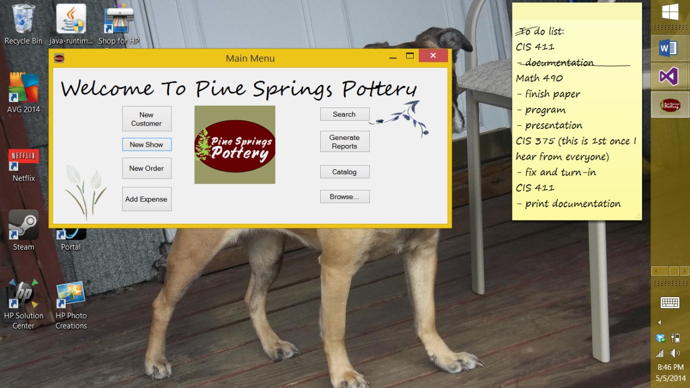

After clicking [New Customer], a blank Customer Information form will open. Enter information into the form as known. The first name and last name fields are needed.

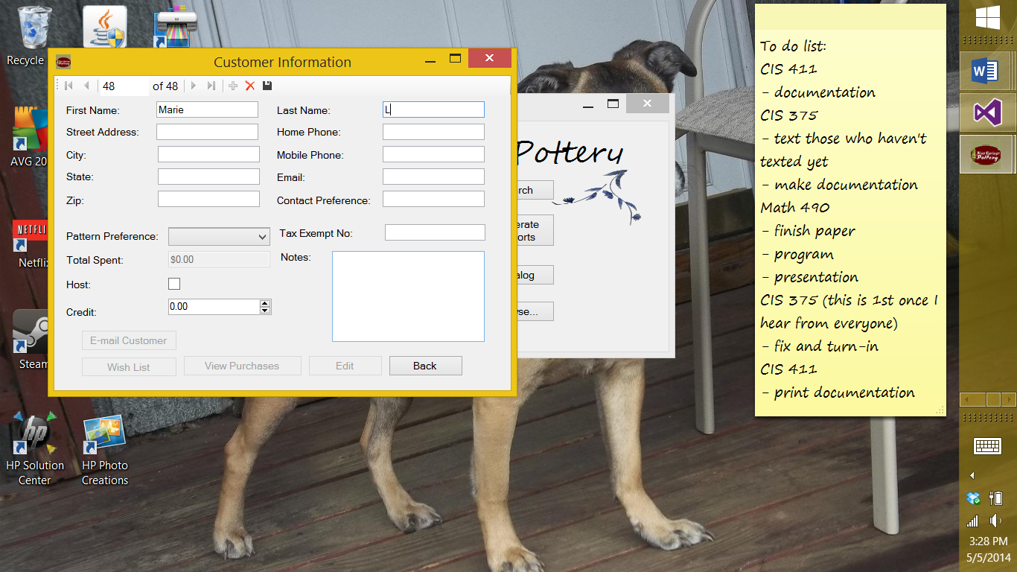

The pattern preference can be chosen through a drop down box, which shows all the patterns.

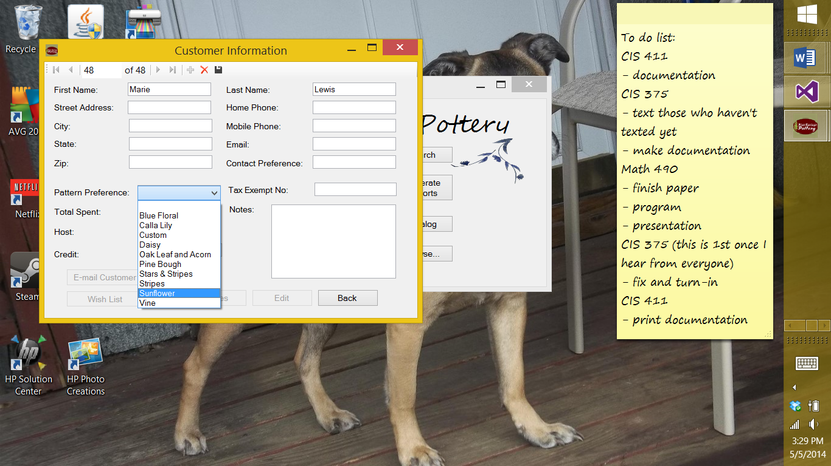

Credit can be adjusted with the up and down arrows on the side of the credit box or type into the box. If the customer is a host, check the “Host” check box (under “Total Spent”).

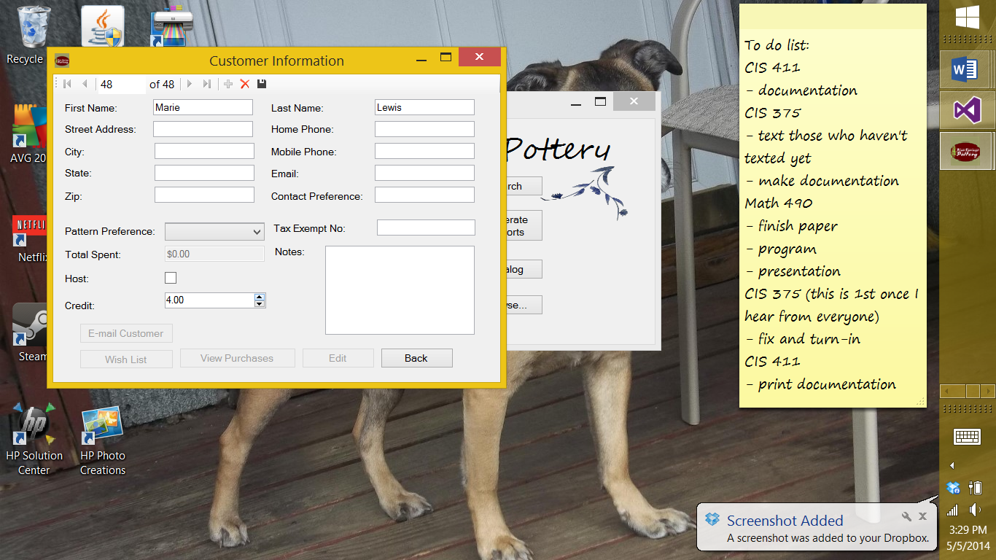

When you are done editing the customer, if you want to save the customer, click the save button at the top of the screen or if you do not want to add the customer, click the delete button at the top of the screen. Once a customer is saved, the customer is checked to see if a first and last name was created and if the first and last name exist for another customer. If a customer already exists with the first name a dialog box will appear asking you if the customers are the same.

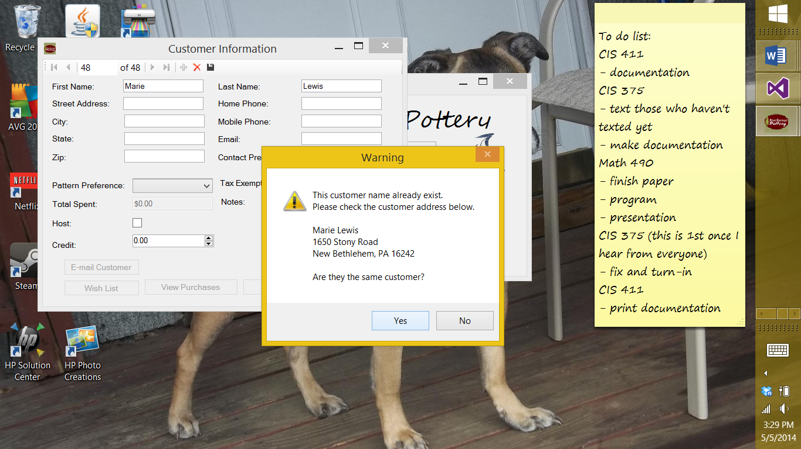

If they are click “Yes” and the new customer will not save and the Customer Information form will go to the customer’s information to be edited. At that point, if you want to edit the customer information click on the edit button or you can navigate through the customers using the arrows at the top of the screen. (Note: Do not forget to save after editing.)

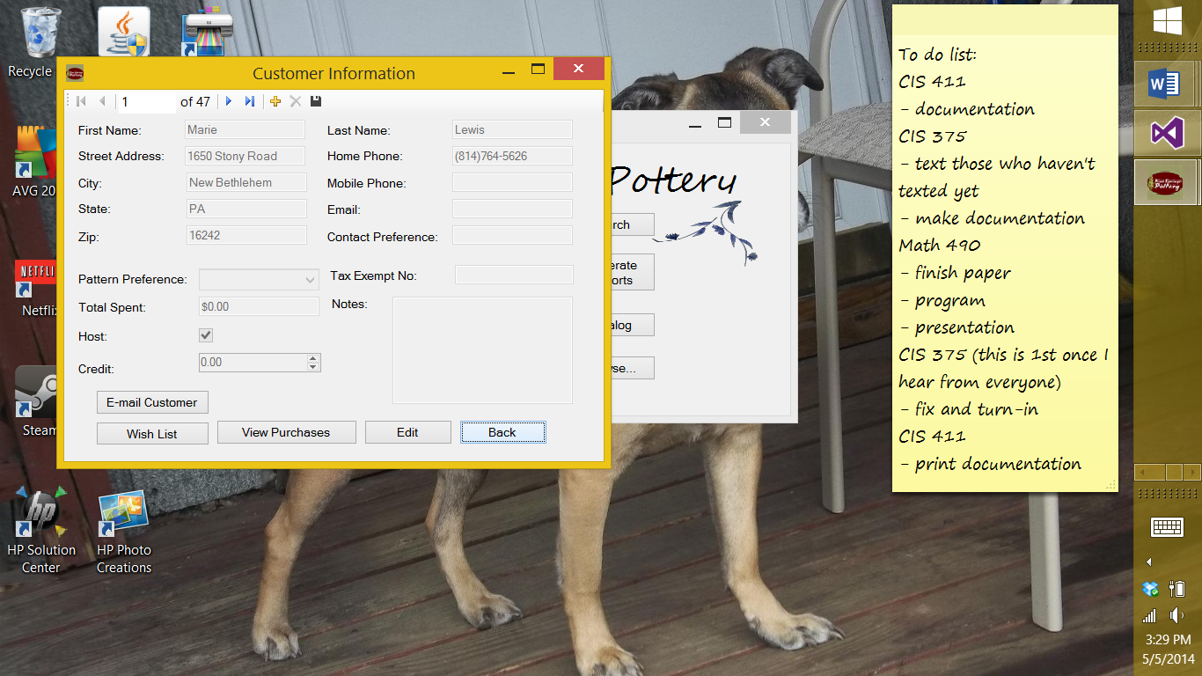

If they are not the same customer, click “No”. This will save the customer and show you the information that was just entered. At this point, you can edit the customer (click edit button), navigate the customers (use arrows).

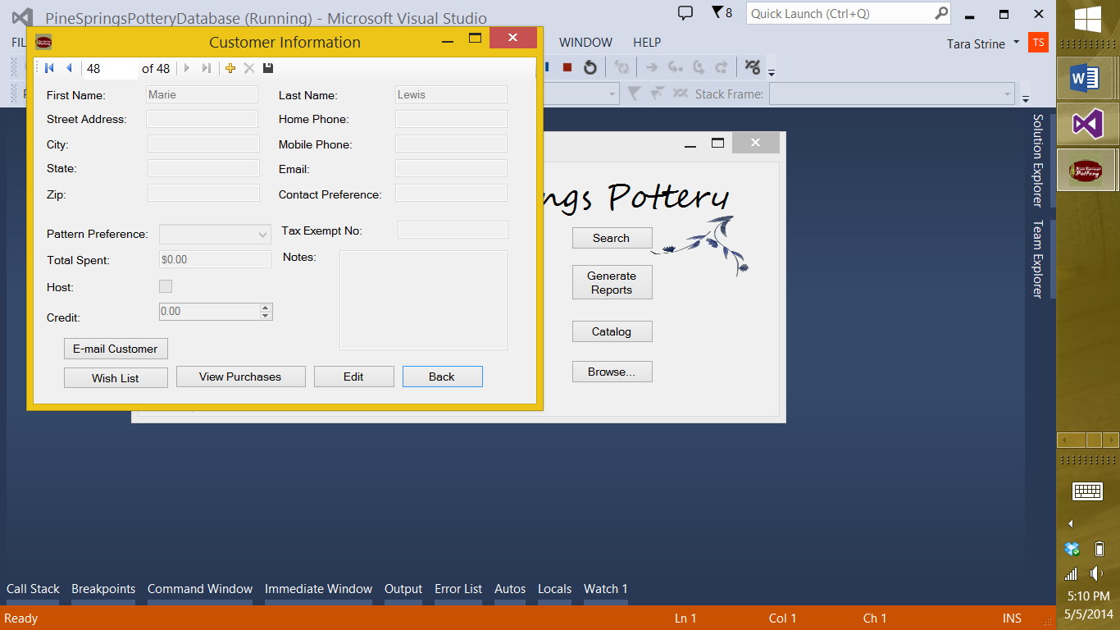

If you open a customer’s information, the Customer Information form will open to that customer’s information filling in all information that is stored. The back button will close the form. See “E-mail Customer”, “Wish List”, and “View Purchases” to learn more about the buttons not mentioned.

## Wish List

After clicking on the “Wish List” button on the Customer Information form, a Wish List form will open adding any wish list items to the table that that customer have. If the customer does not have any wish list item the table will appear empty.

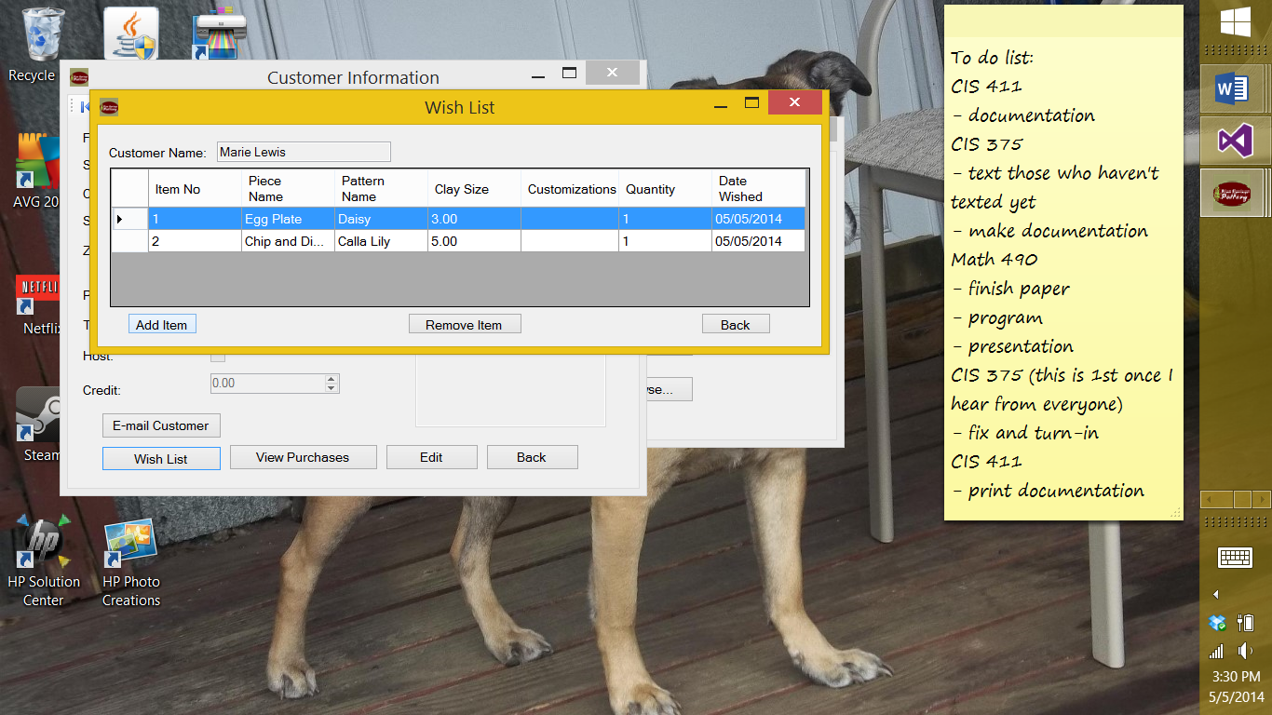

To add an item to the wish list, click “Add Item” and follow the “Catalog” instructions. To remove an item select the row the item is in and click “Remove Item”.

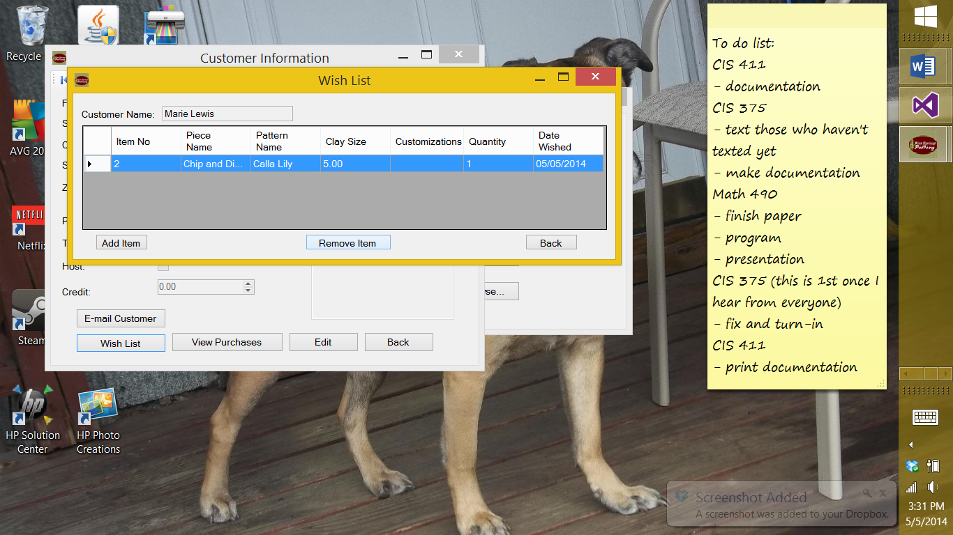

To exit the form, you can click “Back”.

## Order History

After clicking “View Purchases” button on the Customer Information form or searching for order history, an Order History form will open. If there are an orders related to a customer, the orders will fill in the rows.

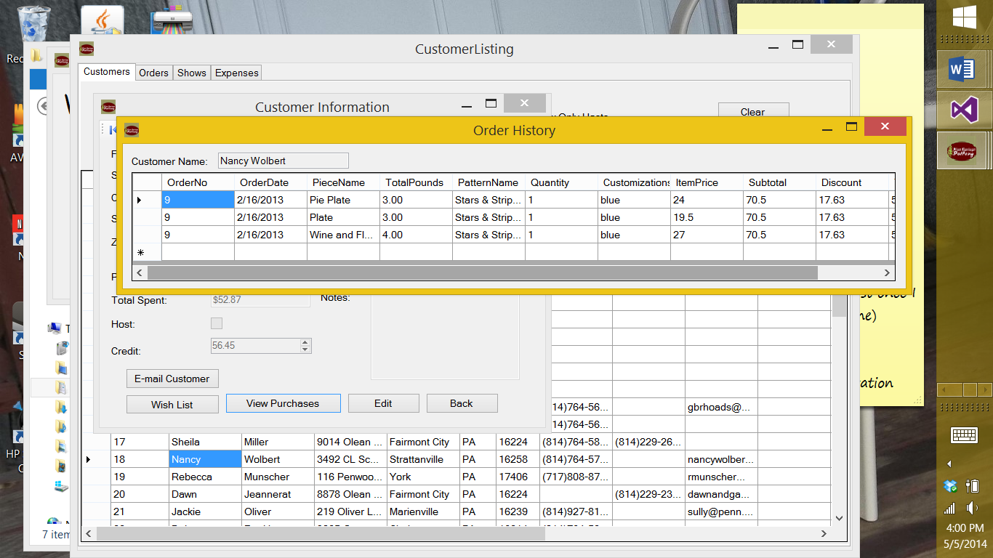

## New Show

After clicking a new show button, a blank Show Information form will open. Enter information into the form as known. A show name, show type, and show date are needed. You can select a show type by the drop down box.

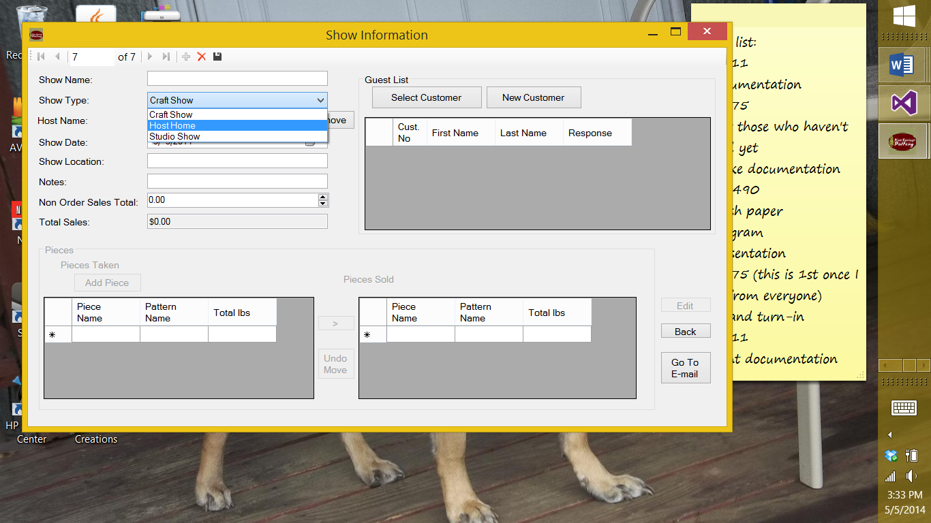

To add a host, click the “Select” button. This will bring you to a customer browse with all the customers listed. Double click on the customer that is the host. If the wrong host is selected click “Remove” and try again. Non Order Sales Total can be adjusted by clicking the arrows in the box or typing in the box.

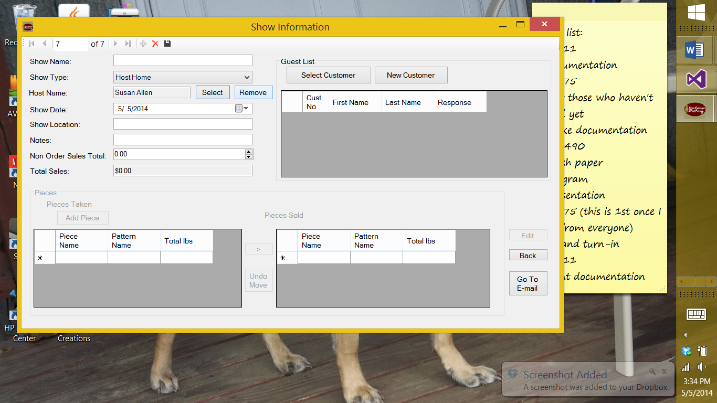

The show date is auto set for the current day, you can change that by clicking on the calendar button to view a calendar and select a day.

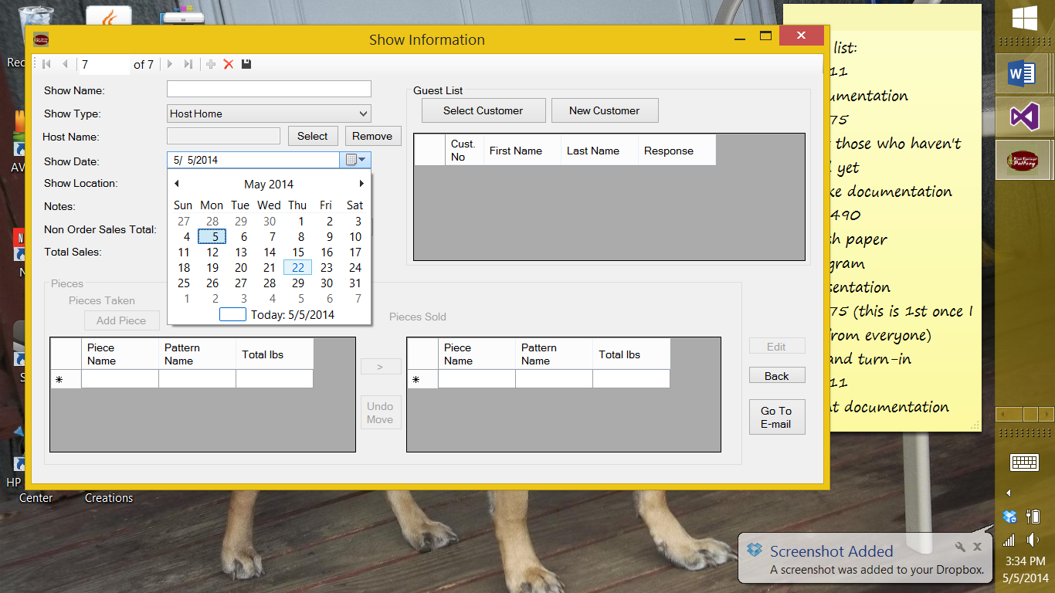

To add guests to a show, click “Select Customer” and browse the customer listings to find the customer you want to add and double click. If the customer does not exist, click “New Customer” and follow the steps for entering a new customer. Once you select a guest, you can change their response it “YES”, “NO”, or “NORESPONSE” using the drop down box. At this point, you can show the show or chose to delete it. (Note: once you save a show you cannot delete it.)

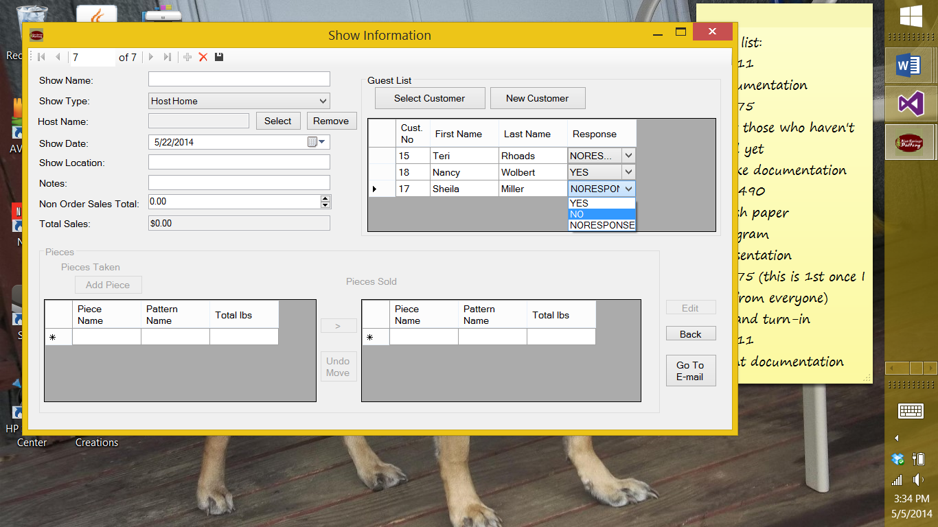

After saving a show or opening a pre-existing show, you can navigate the shows with the arrow buttons at the top of the form or you can edit the show. At this time you can enter any pieces that you are planning to take to the show by clicking the “Add Piece” button (Follow Catalog instructions).

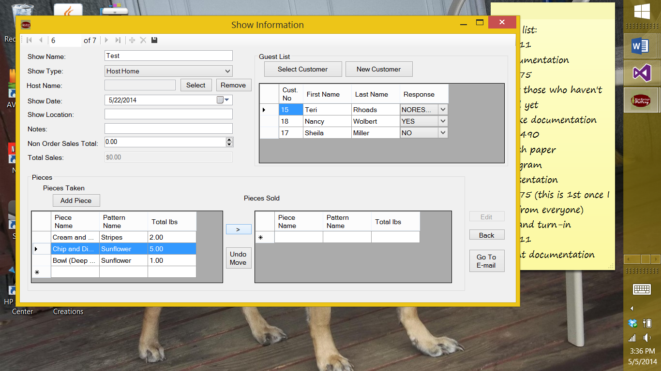

If you sell a piece that you took to the show, you can mark it as sold by selecting the row the piece is in in the Pieces Taken table and click the “>” button and if you relies that it was not sold, you can fix that by selecting the piece again in the Pieces Sold table and click “Undo Move”.

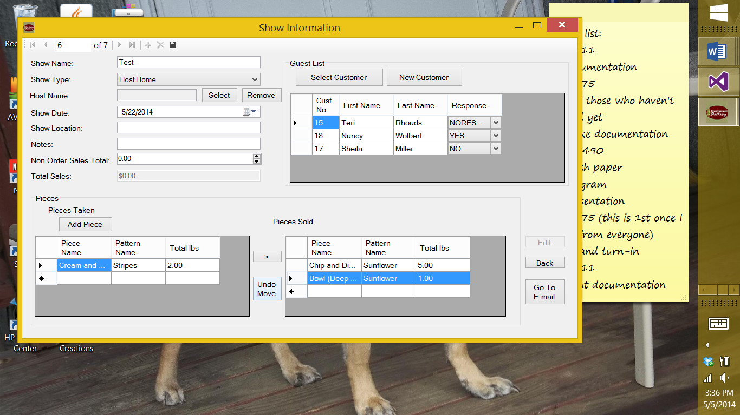

The “Back” button will close the form. See “E-mail” for the “Go To E-mail” button.

## Entering a New Order

1. From the Main Menu, click [New Order] to bring up a screen like below.

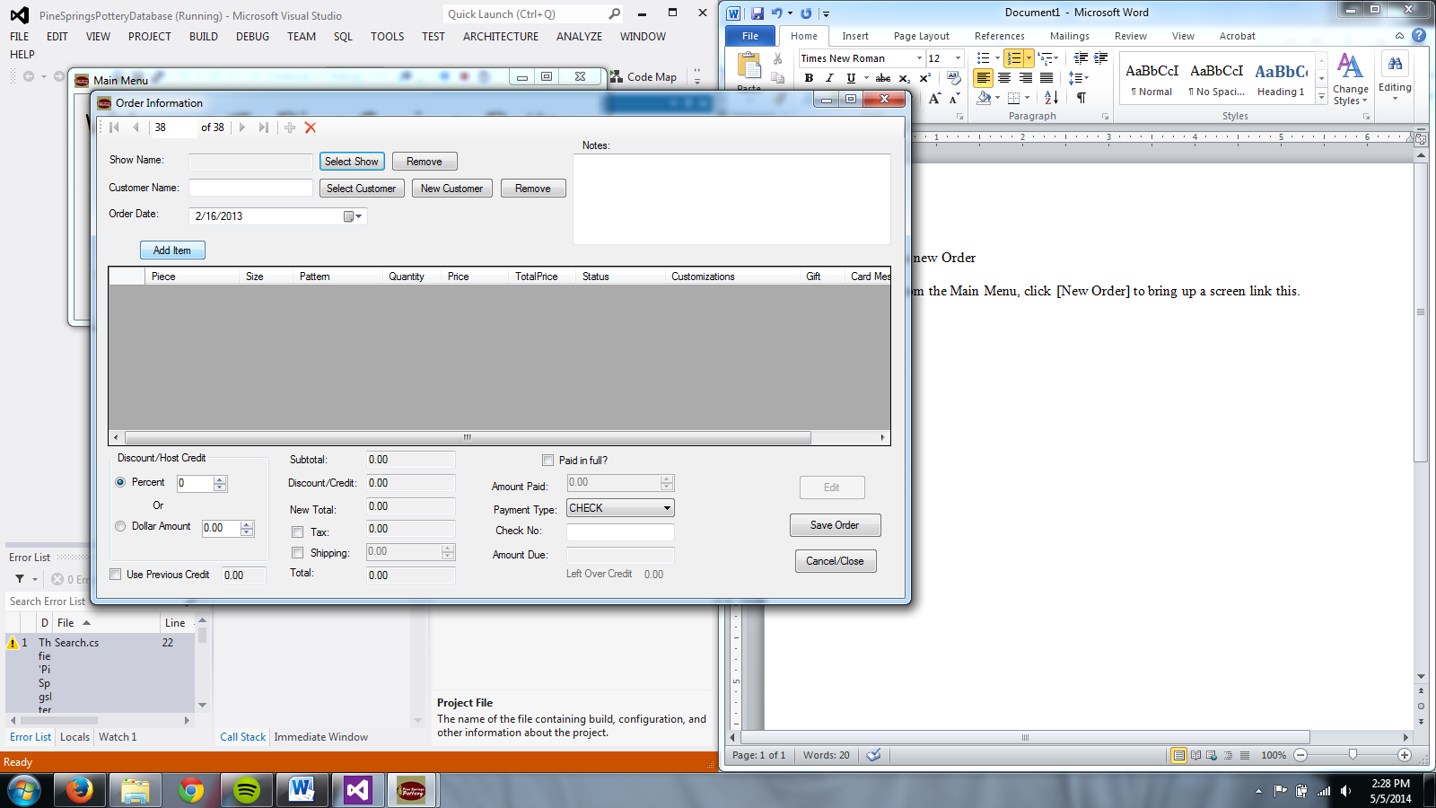

1. To add this order to a specfic show, click [Select Show], and double click on the desired show.

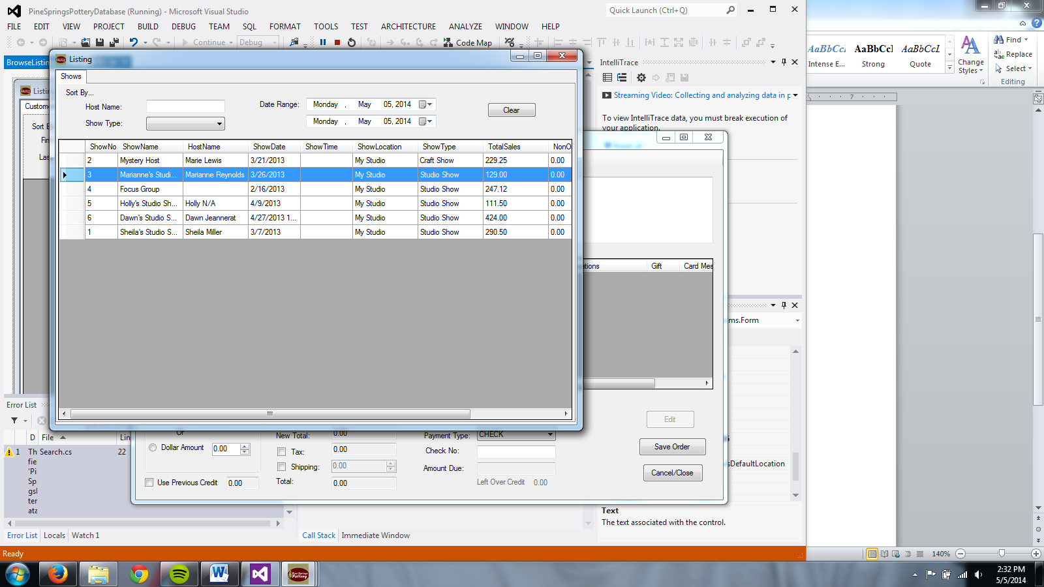

You will see the name and date of the selected show appear on the order form.

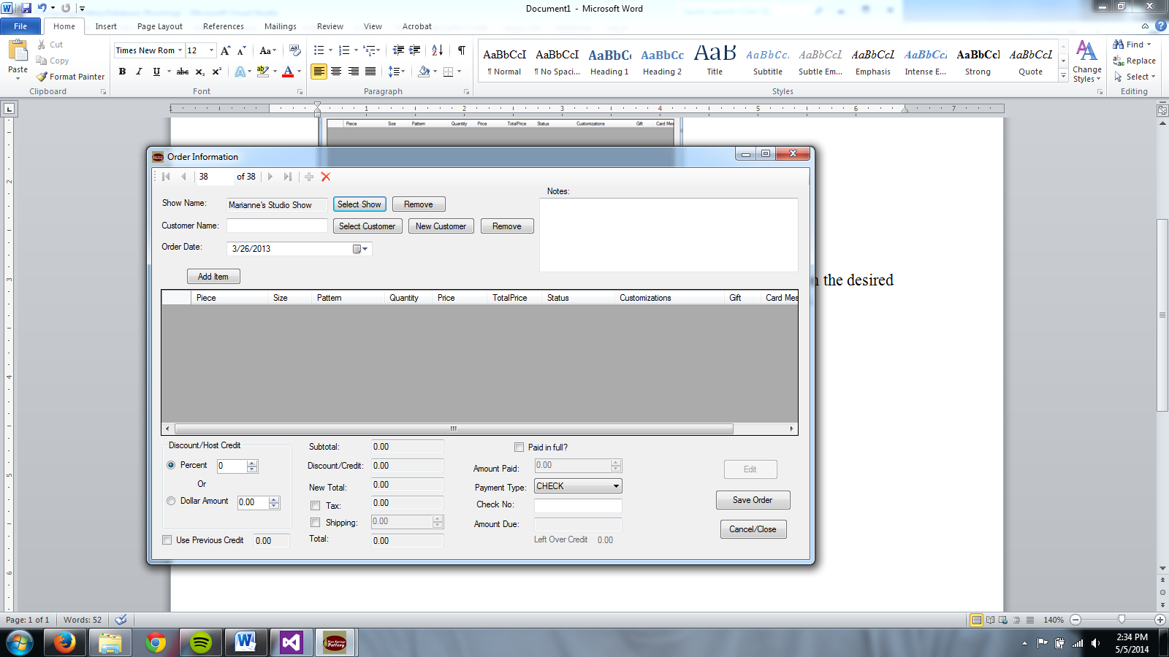

The show may be changed by clicking [Select Show] again. The show may be removed by clicking [Remove] next to the show.

1. To add a customer to this order, click [Select Customer], and double click on the desired customer.

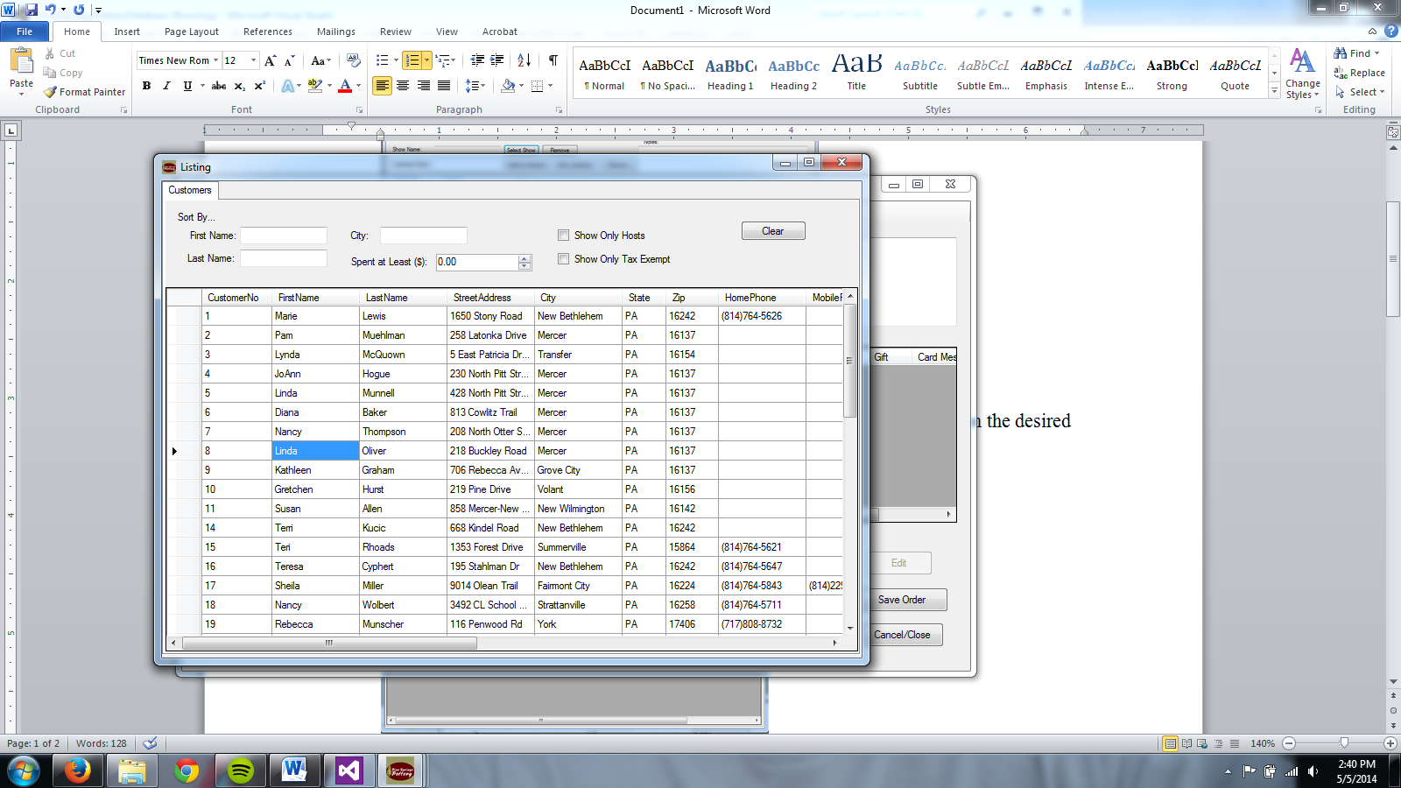

You will see the name of the selected customer appear on the order form.

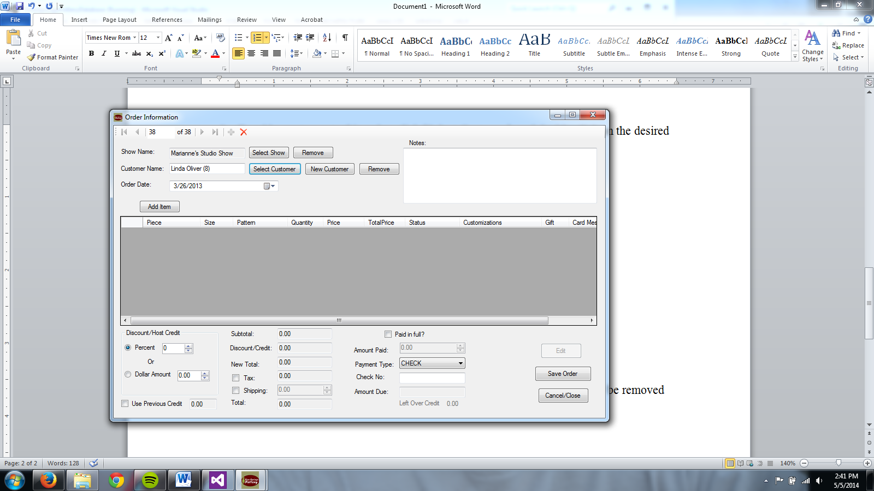

The customer may be changed by clicking [Select Customer] again. The customer may be removed by clicking [Remove] next to the customer.

The customer may also be selected by AutoComplete. Start typing the first name of the customer, navigate to the right one, and click or hit enter.   
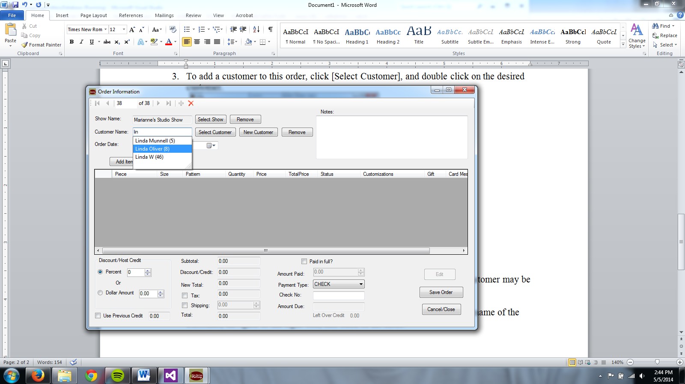

You may also enter a new cutomer by clicking [New Customer] and following the instructions for “Entering a New Customer.” After that customer is saved, you may now select him/her from [Select Cutomer].

1. You may change the day of the order using the Calender tool.

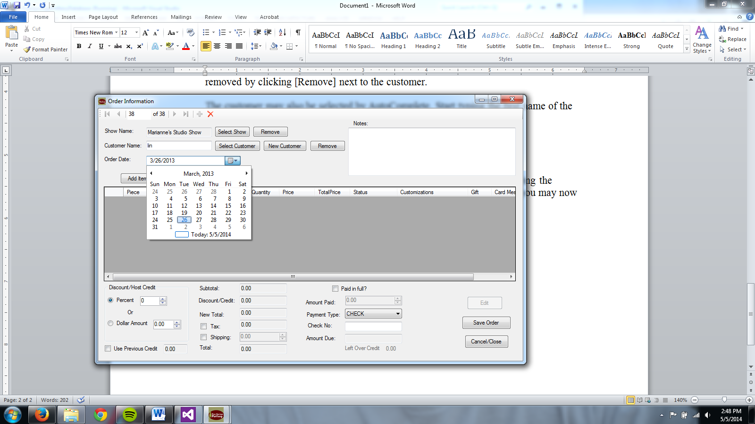

1. To add an item to the order, click [Add Item], which will bring up your catalog.

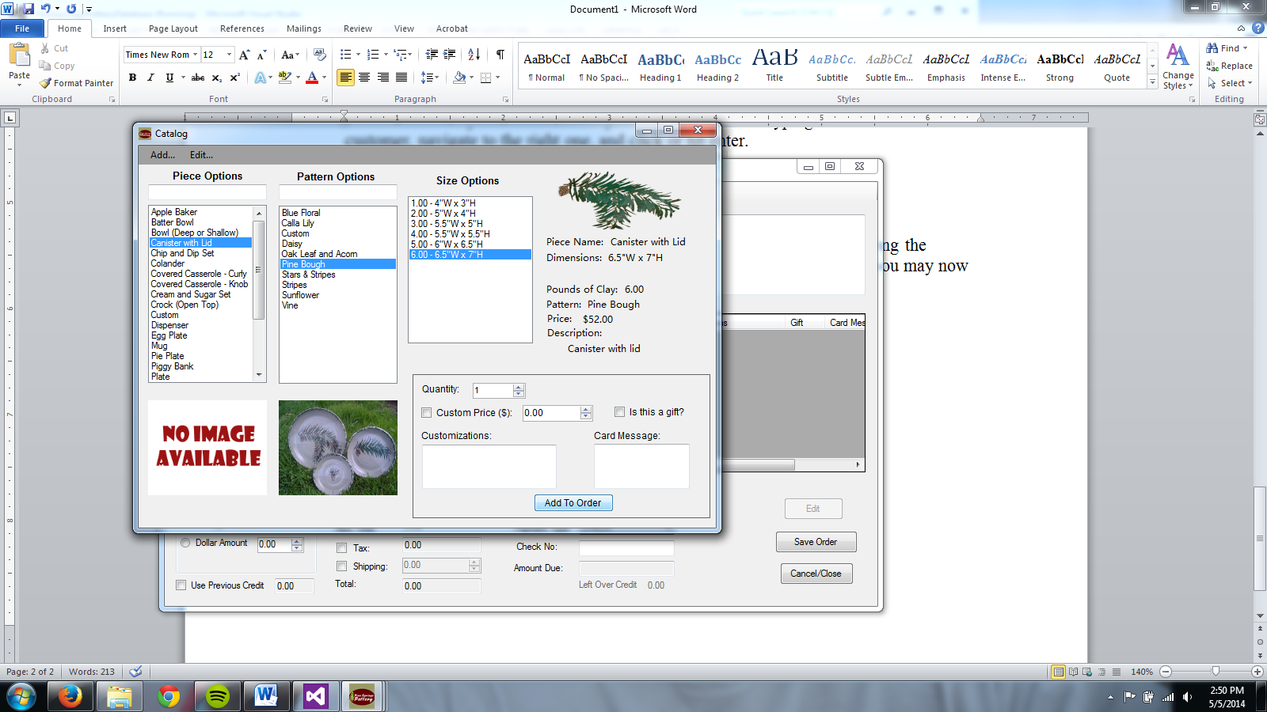

Select the piece, pattern and size by clicking on the corresponding options. The details will show on the right-hand side. The selected piece and pattern will show in the pictures below. The input boxes for piece and pattern may be used for searching and will limit the options to match your search.   
 To change the quantity, enter the desired quantity in the quantity box. You may also change the price by checking the box next to “Custom Price” and entering a new value. There is also input for customizations, gift option, and a card message.  
 Click [Add To Order] to add the item.

1. The item will now appear in the order screen. 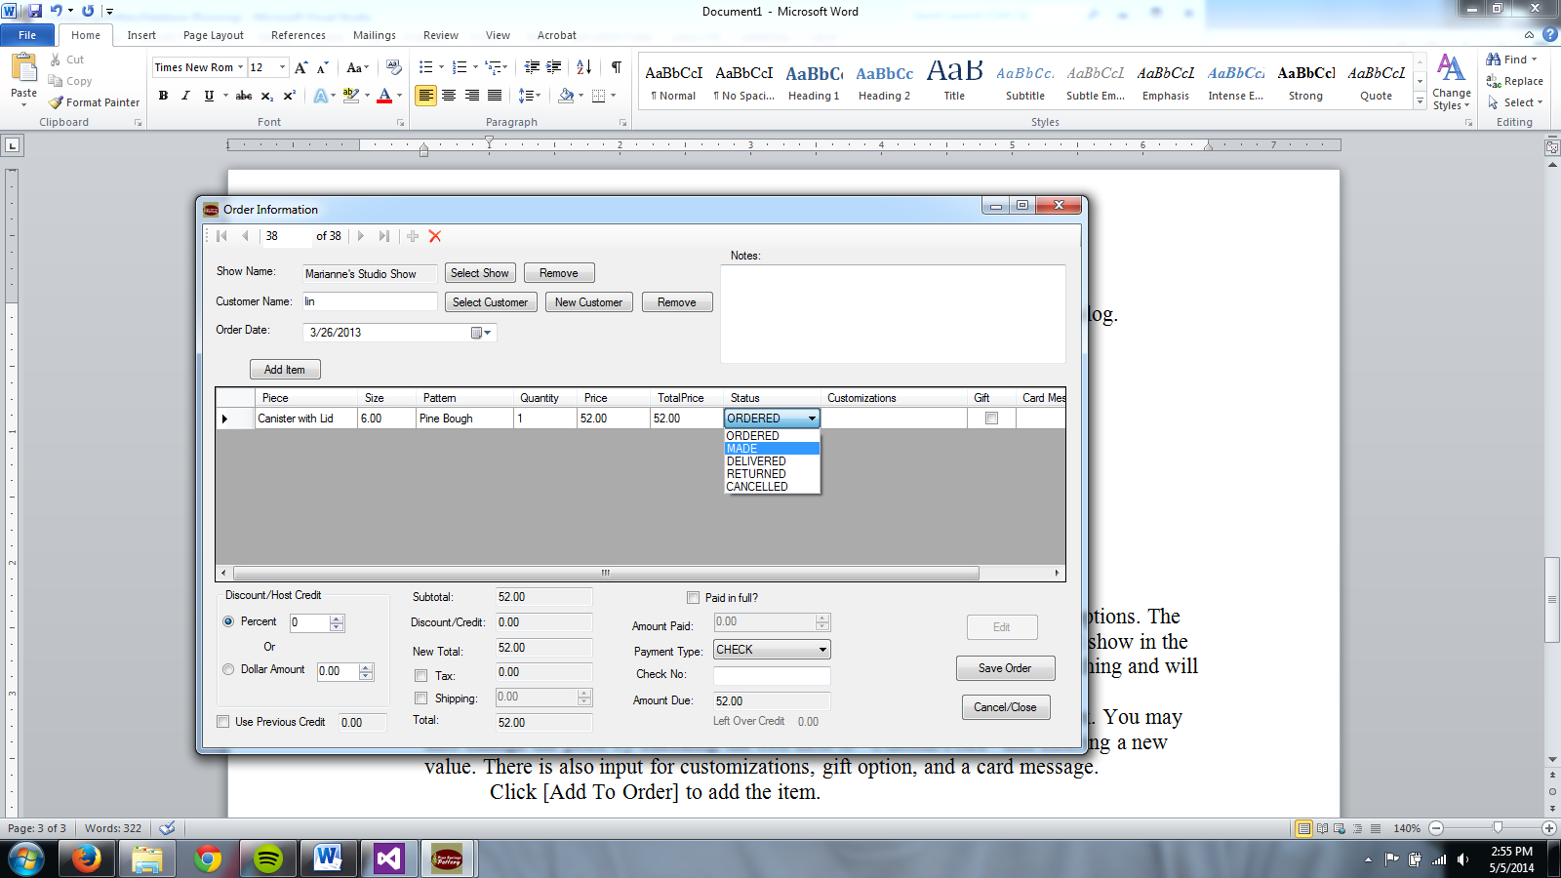

You can still change the quantity, price, status, customizations,gift option,and card message from this screen.

To delete an item, click on the far left box of that row to select the whole row and hit “Delete”on your keyboard.

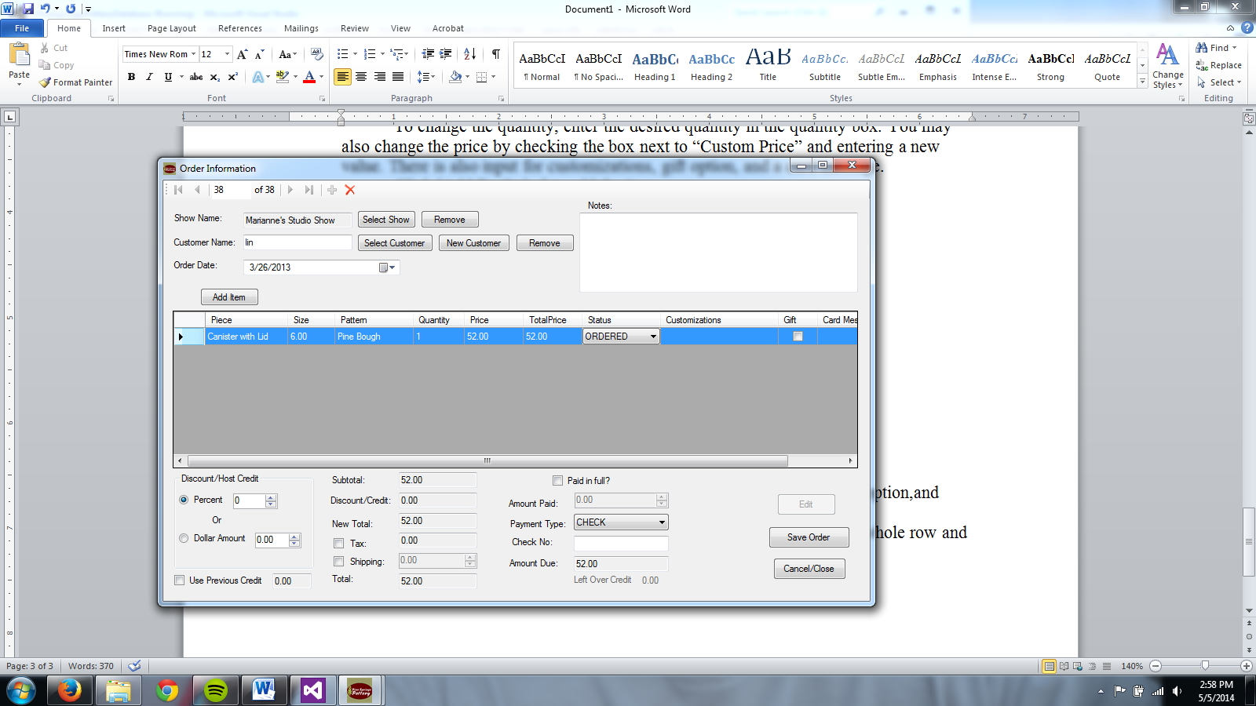

You may continue to add items until the order is filled.

1. You can add an overall discount to the order by percent or dollar amount. Also if the selected customer has credit, it will show below the discount box. To use the credit, click the checkbox next to “Use Previous Credit”.



1. The order’s money summery appears at the bottom of the screen.

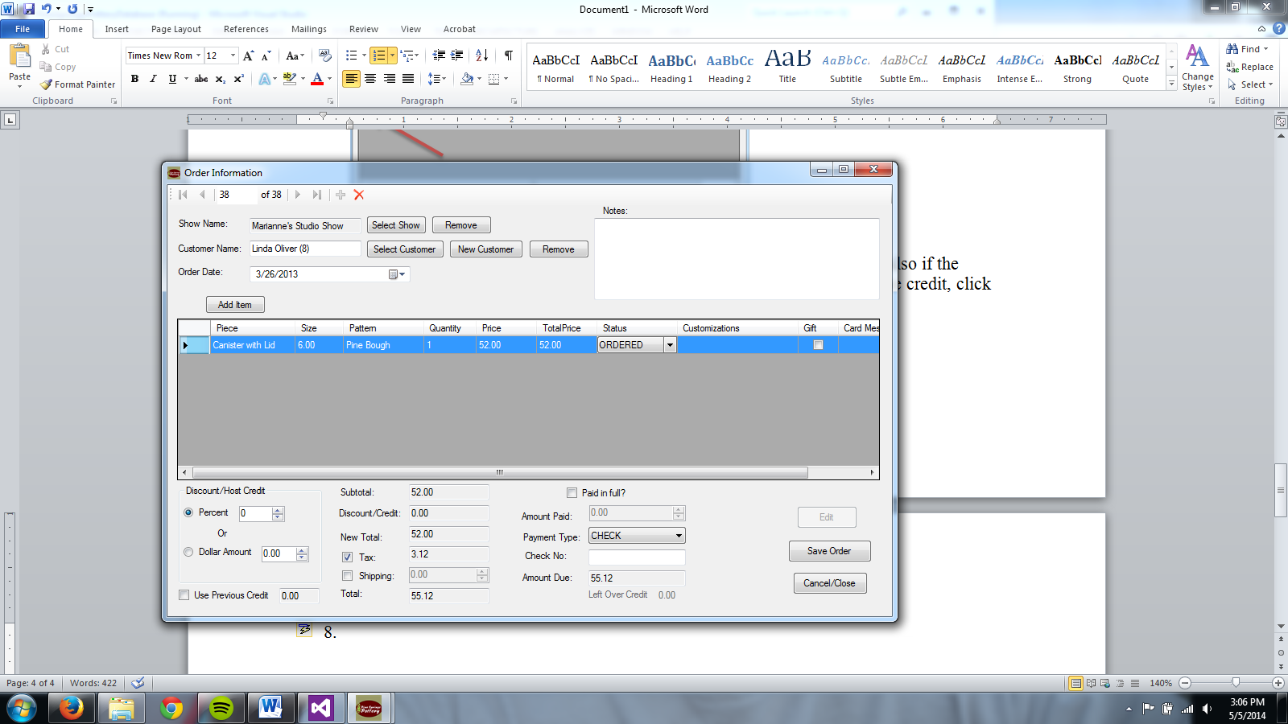

Add tax by clicking the checkbox next to “Tax”, and it will be auto-calculated.

Add shipping by clicking the checkbox next to “Shipping” and entering the amount.

If the customer paid in full, click the checkbox to autofill in the amount paid. If they did not pay in full, enter in the amount they paid and the amount they owe will be displayed.

Select the payment type from the dropdown box. If check is selected, a place to enter the check number will be provided.

1. Click [Save Order] to save the order.

Click [Close/Cancel] or the red X at the top to cancel adding the order.

## Viewing an Order

1. Order information may be opened from another form or viewed from [New Order].
2. After a new order is saved or cancelled, the order information is displayed like below.

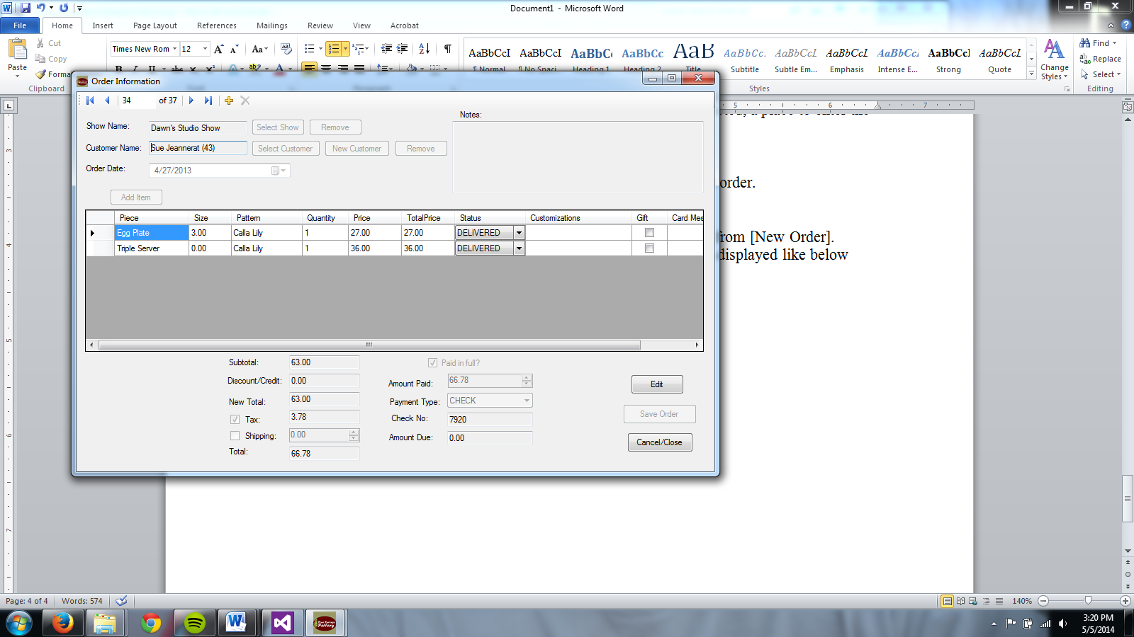

1. The blue arrows will navigate the orders. The yellow plus will add a new order.
2. Customizations and Card Message may be view easier by double clicking on it.

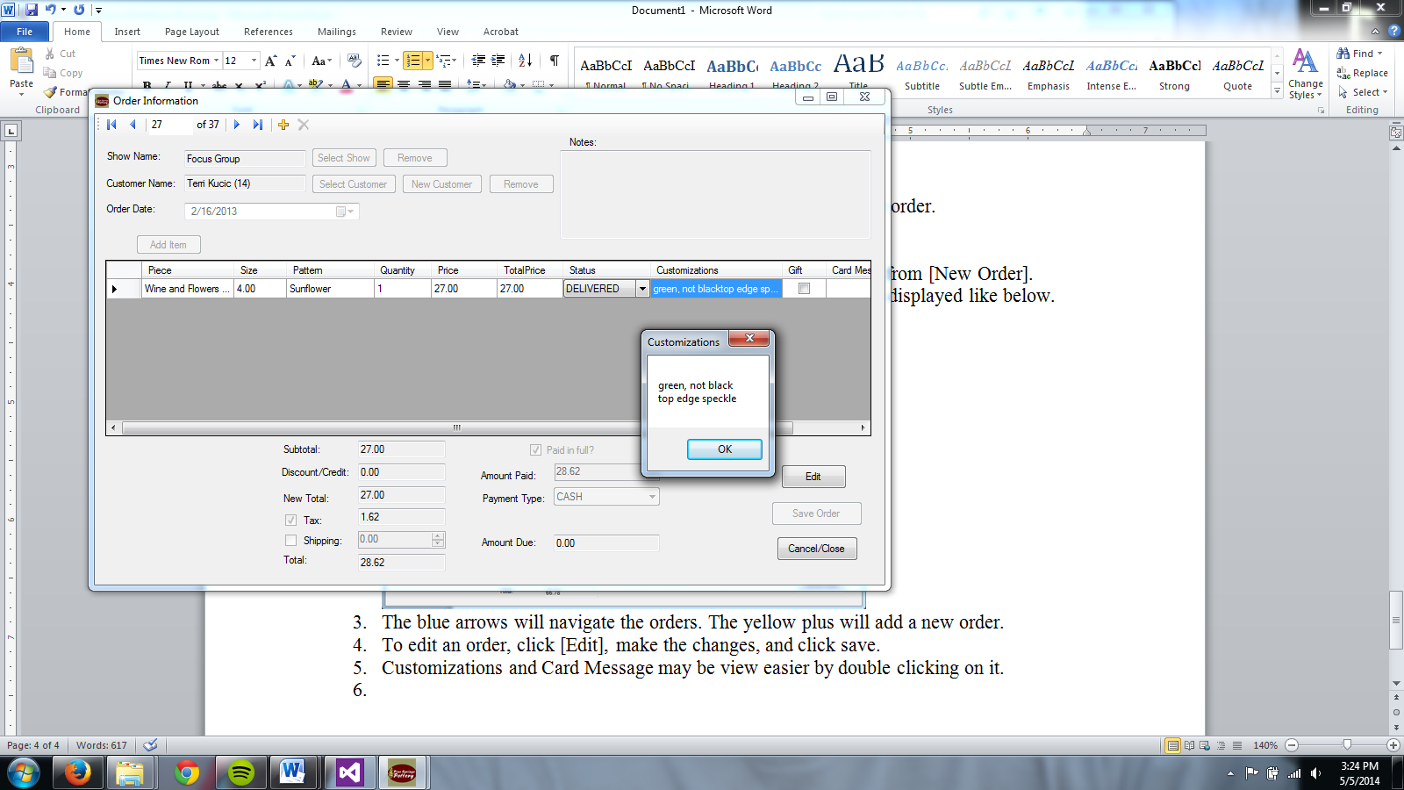

1. To edit an order, click [Edit], make the changes, and click save.

## Adding an Expense

1. From the Main Menu, click [Add Expense].

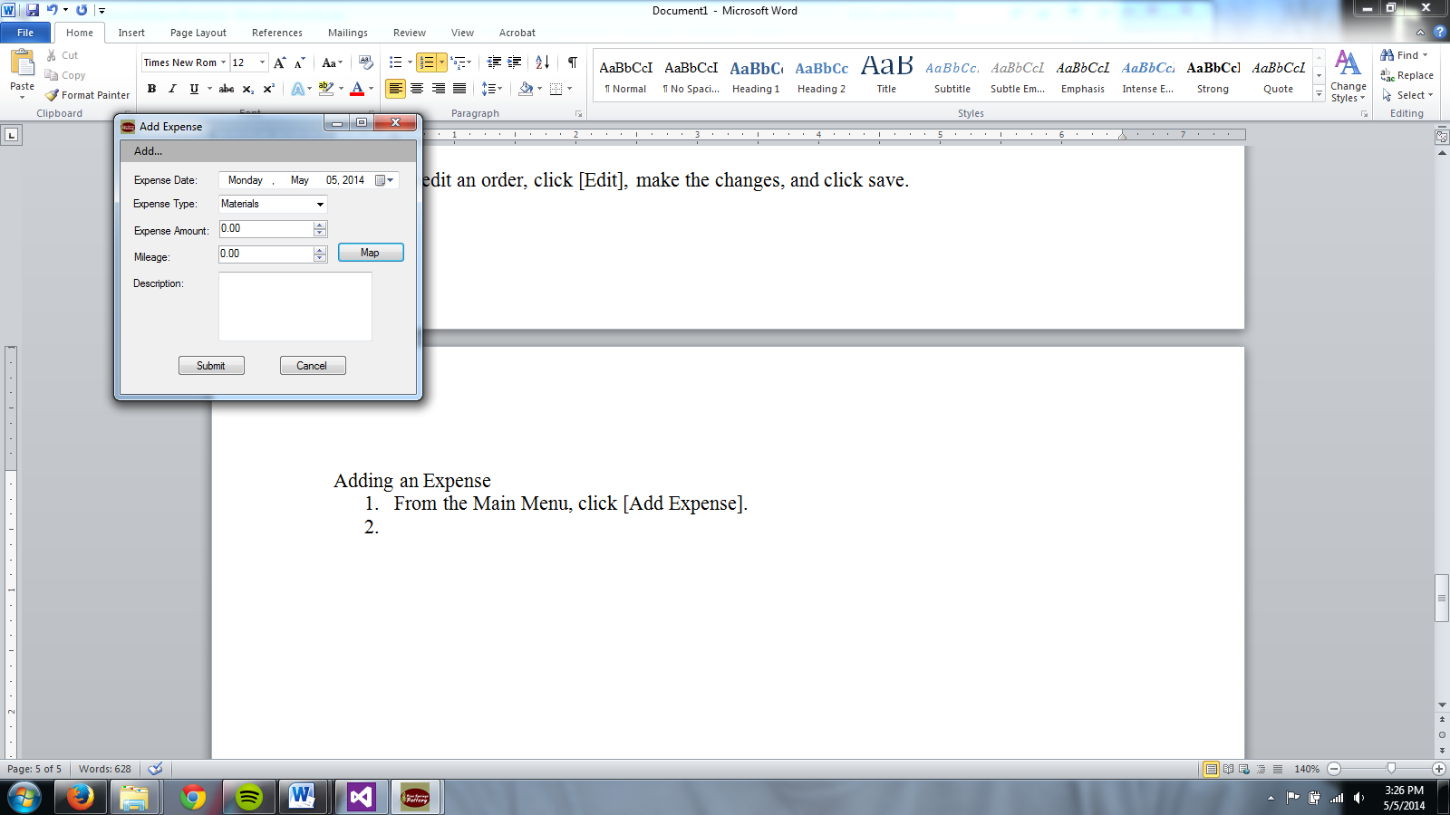

1. Choose the date and type of expense.
   1. If a new type of expense is needed, click “Add…” then “Expense Type”

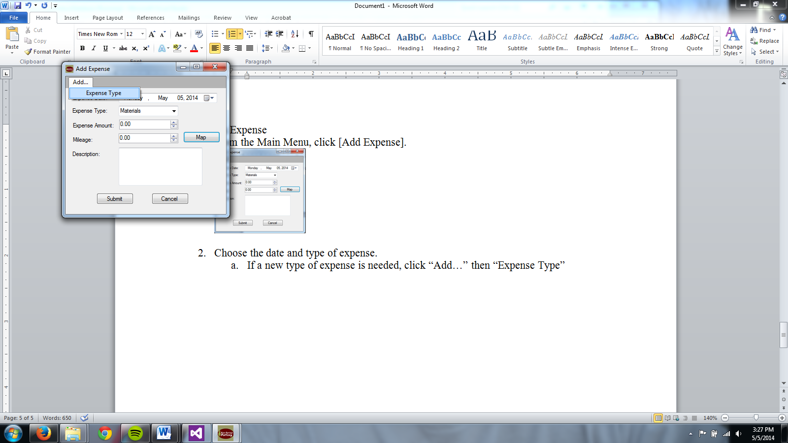 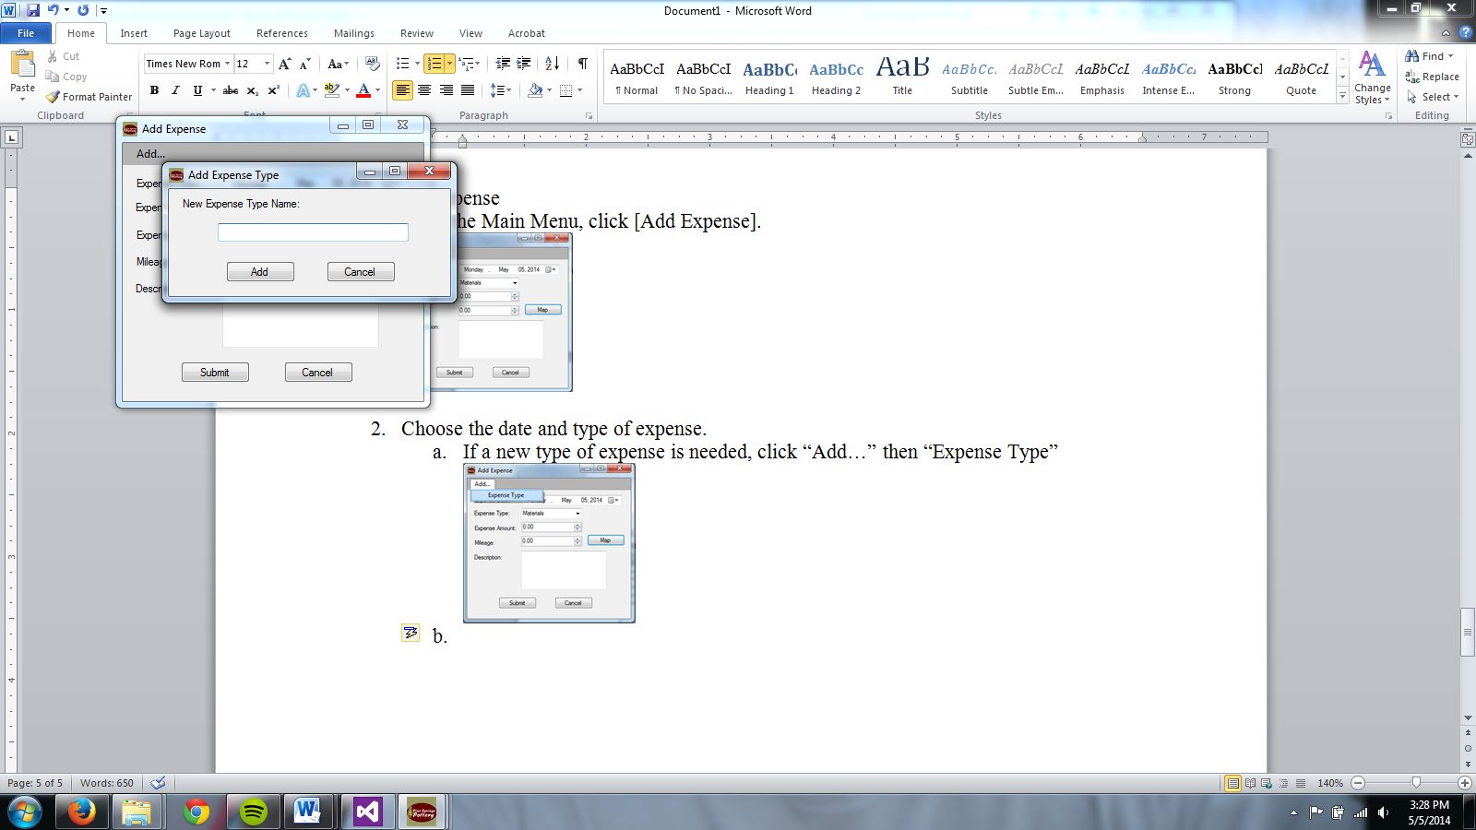

* 1. Type in the name for the new expense type and click [Add].
  2. Click [Cancel] to go back without adding a type.

1. Enter the amount for the expense and mileage if applicable.
   1. Click [Map] for quick access to Google™ maps for mileage calculations.
2. Add a description of the expense, if desired.
3. Click [Submit] to save the expense or [Cancel] to go back to the Main Menu.

## Editing the Catalog

1. From the Main Menu, click [Catalog].

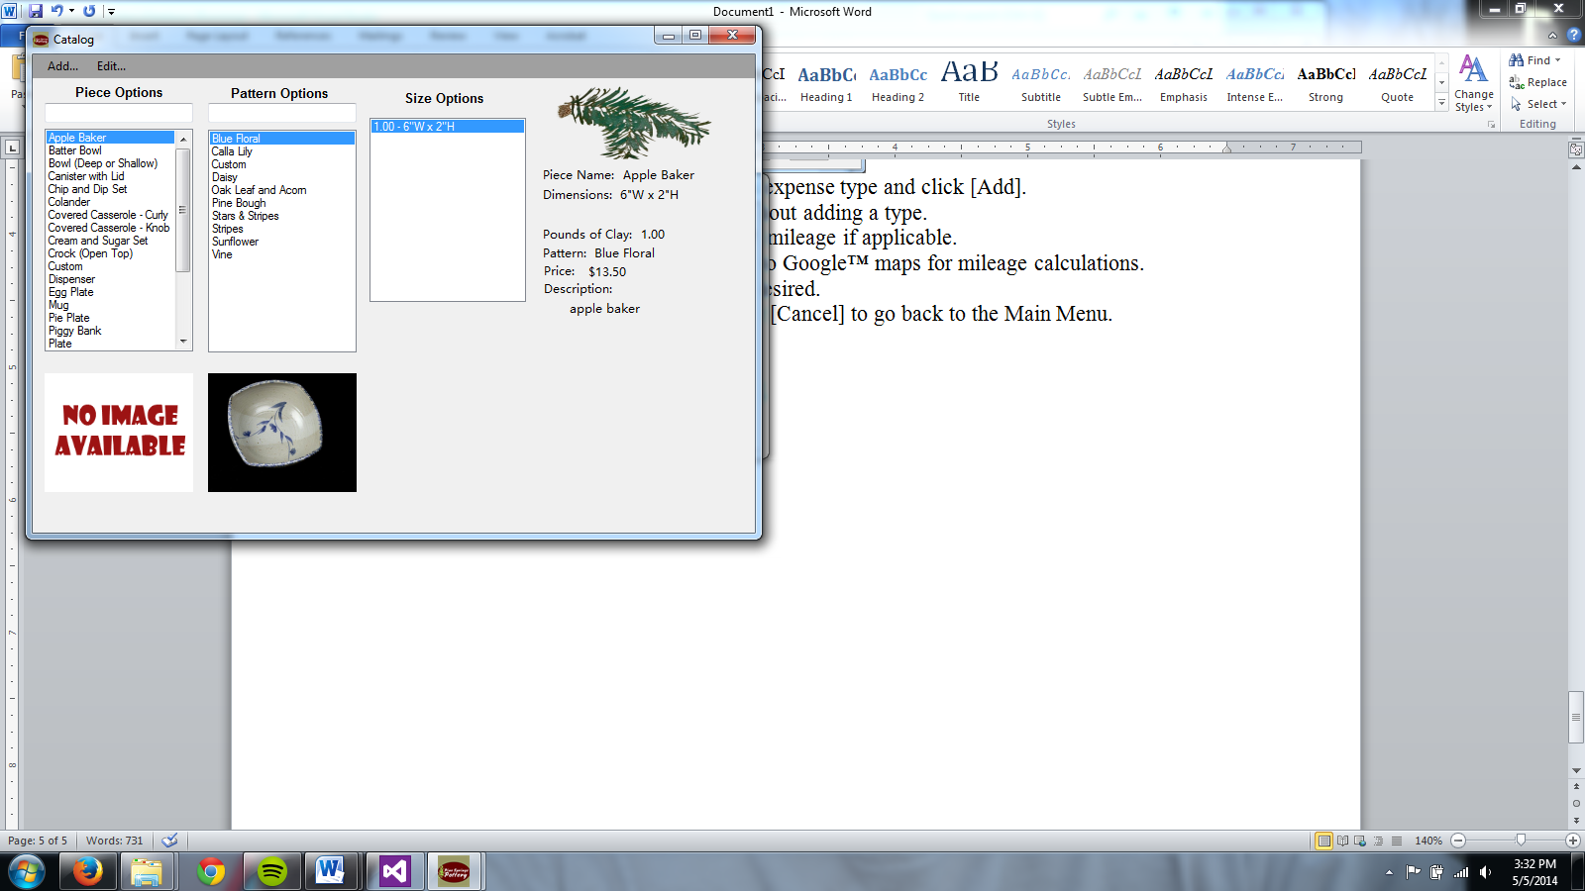

1. To add a piece, click “Add…” and “New Piece” or to edit the selected piece click “Edit” and “Piece.”

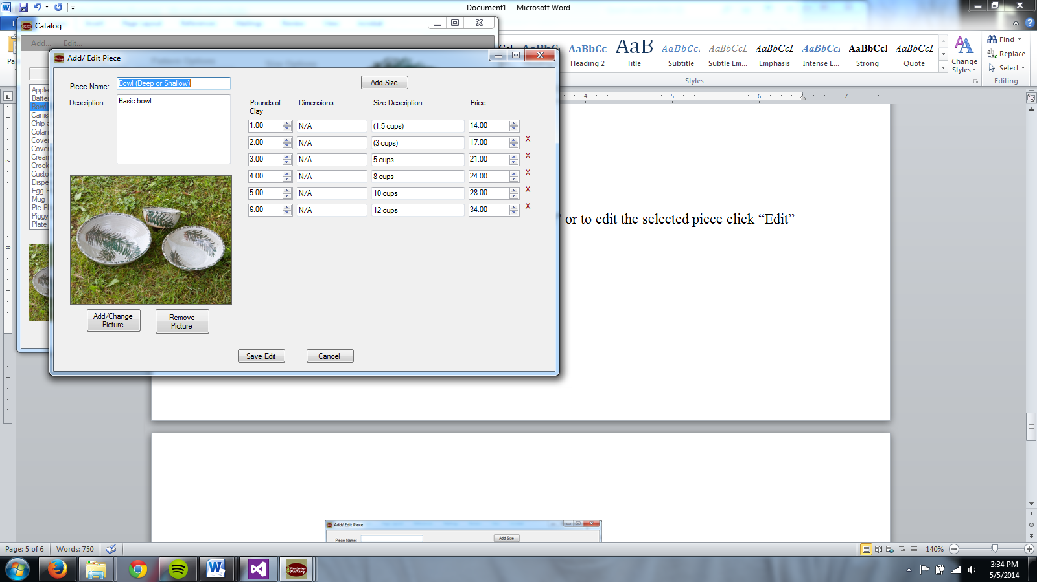

* 1. Enter a name and descripiton for the piece
  2. Add/Change/Remove the picture.
  3. Add/Edit information about each size on the right.
     1. Add a new size option by clicking [Add Size].
     2. Remove a size option by clicking the red X on the right of the price.
  4. Click save to save the new piece or save changes.
  5. Click cancel to go back to the catalog without making changes.

1. To add a pattern, click “Add…” and “New Pattern” or to edit the selected pattern click “Edit” and “Pattern.”

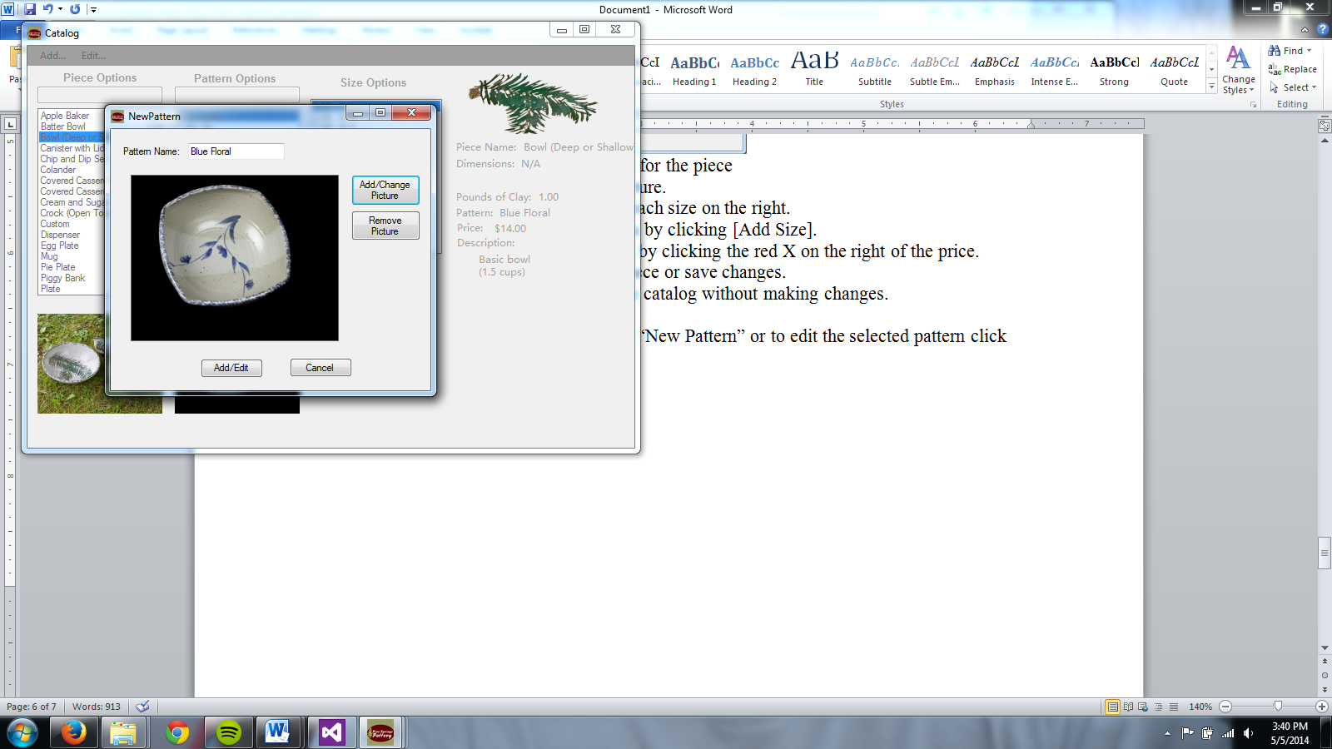

* 1. Enter a name for the pattern
  2. Add/Change/Remove the picture.
  3. Click save to save the new pattern or save changes.
  4. Click cancel to go back to the catalog without making changes.

## Browsing Customers/Orders/Shows/Expenses

1. From the Main Menu, click [Browse] to bring up a screen like below.  
   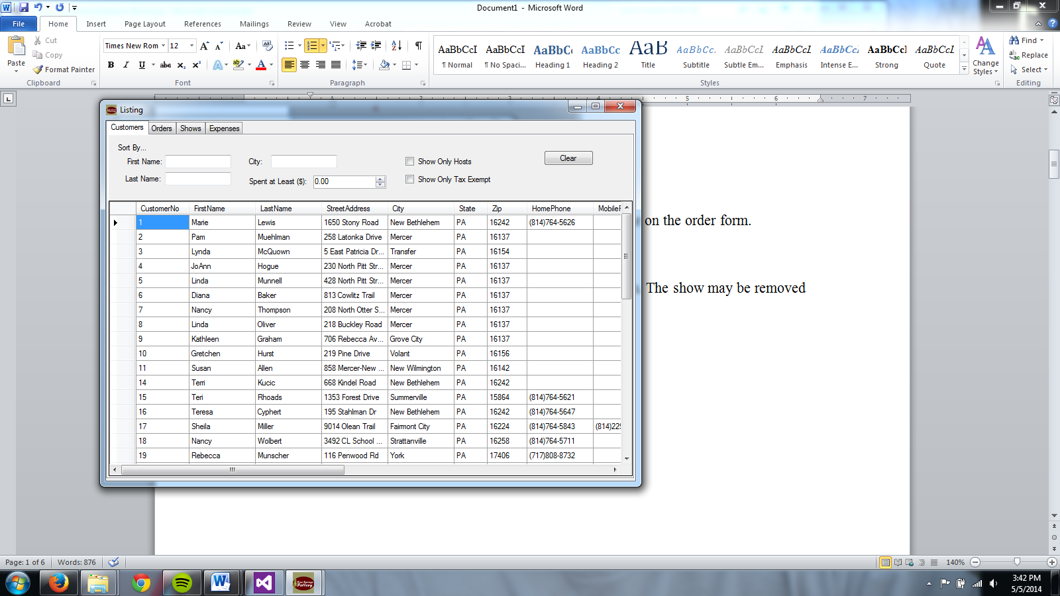
2. Click the tab at the top for the desired category to browse.
3. Enter information to limit the results displayed in the grid.
4. Click clear to reset the results and clear all criteria.
5. Double click on a cell for any item to bring up a screen with its details.

## Searching

1. From the drop-down menu select the desired search option
   1. Customer Name
   2. Host Name
   3. Show Name
   4. Show Date
   5. Order Date
   6. Orders of a Customer
   7. Receivables (Partially Paid/Unpaid)
   8. Undelivered
   9. Pattern
   10. Piece
2. Enter search criteria and click search

For Customer Name, Host Name, Show Name, and Orders of a Customer the enter the criteria in the search box

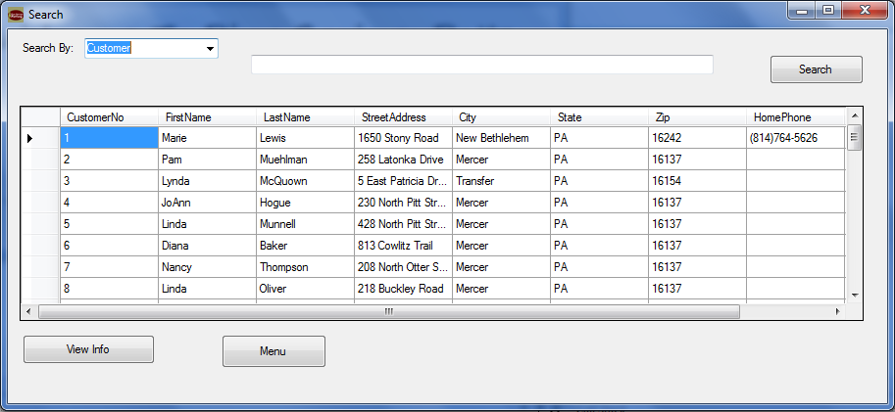

For Show Date or Order Date select the start of the date range and the end of the date range from the calendar tool

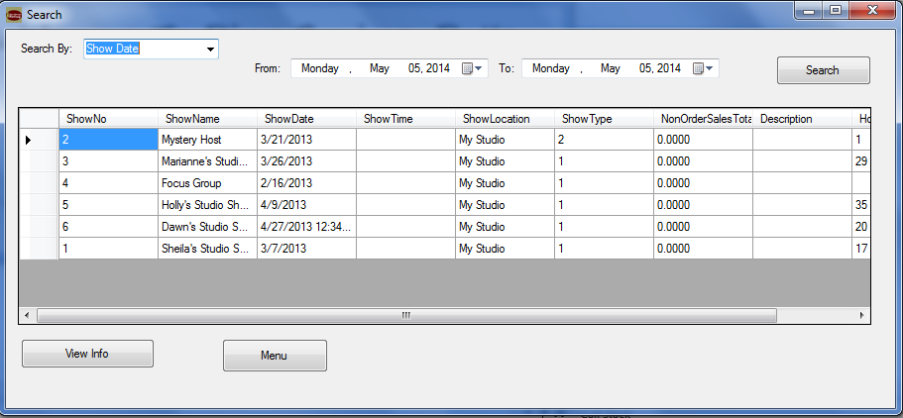

For search by receivables and undelivered, the table will fill as soon as the search by option is changed.

For search by pattern or piece, select the pattern (or piece) and the start & end dates

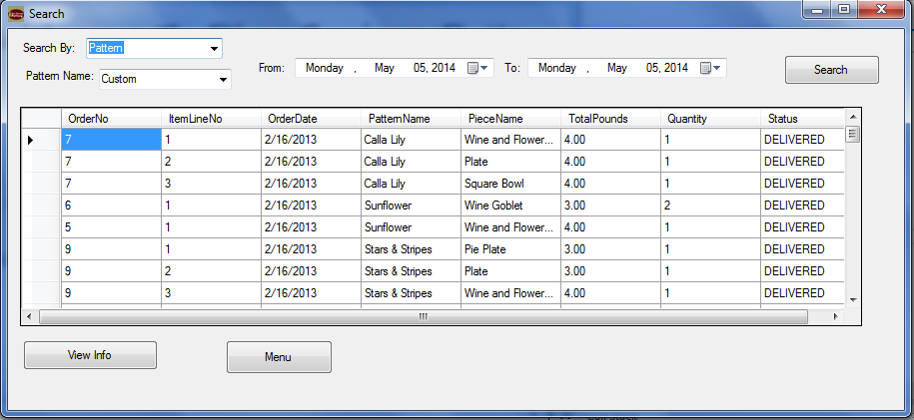

1. To view info of a result
   1. Click that row of the table
   2. Click view info button and the information for that entry will open
      1. Customer & receivables opens Customer Information
      2. Host Name, Show Name, and Show Date open show information
      3. Order Date, Pattern, and Piece open order information
      4. Orders by Customer opens order history of customer
      5. Undelivered does not link to any information

# Generate Reports

On the Main Menu, click [Generate Reports]. The screen below will show. All the forms allow you to search through them, save them, or print them. The first tab is Delivery Report. This report lets you choose a date that a show was on and create a report of all the orders that need to be delivered for that show.

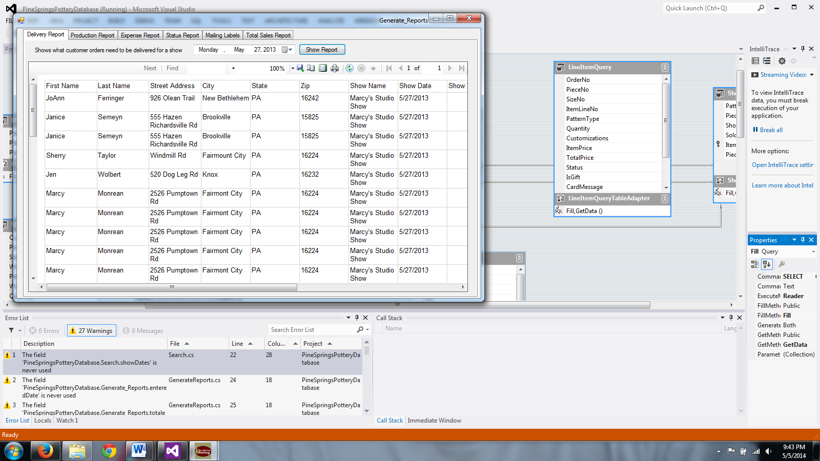

On the second tab, we find the Production Report. This report allows us to choose a day range and builds a report that shows what was produced in that range after clicking [Show Report].

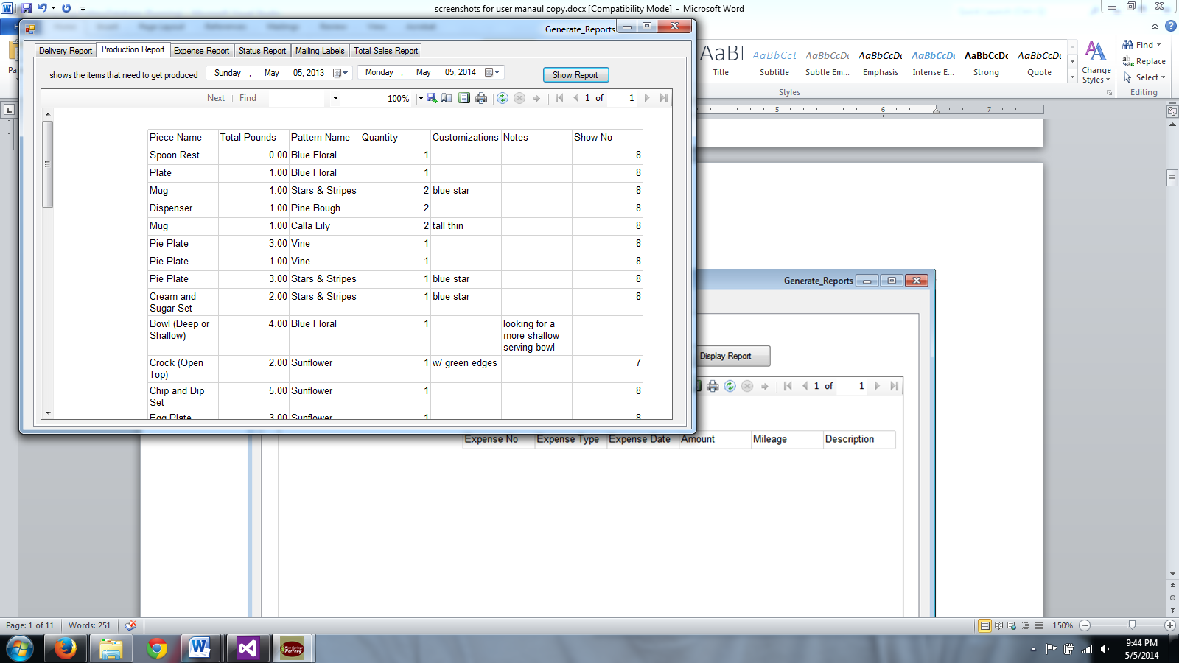

On the third tab, Expense Report makes a report of all the expenses that exist in a given date range.

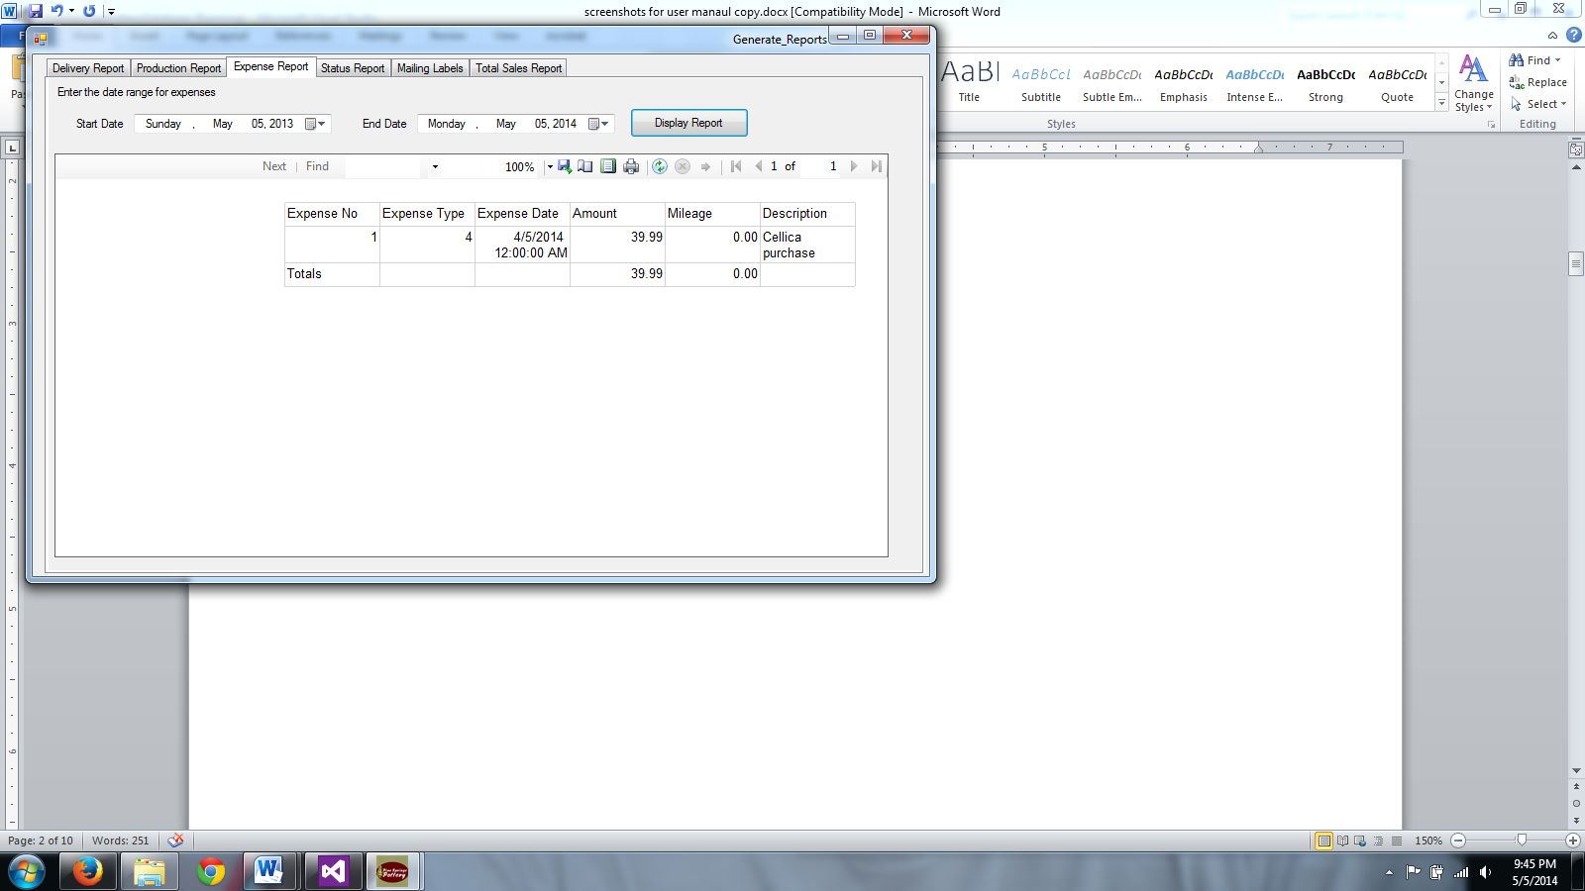

This is a screenshot of the status report; it shows any orders that are not paid or that are not delivered.

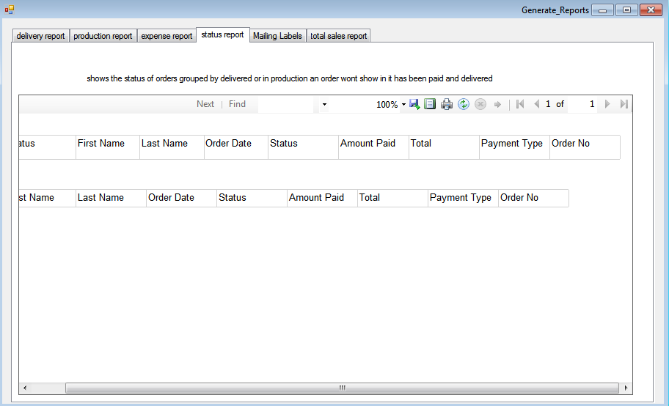

This is a way to create mailing labels (there is also a second from the Access database).

First, select a customer.

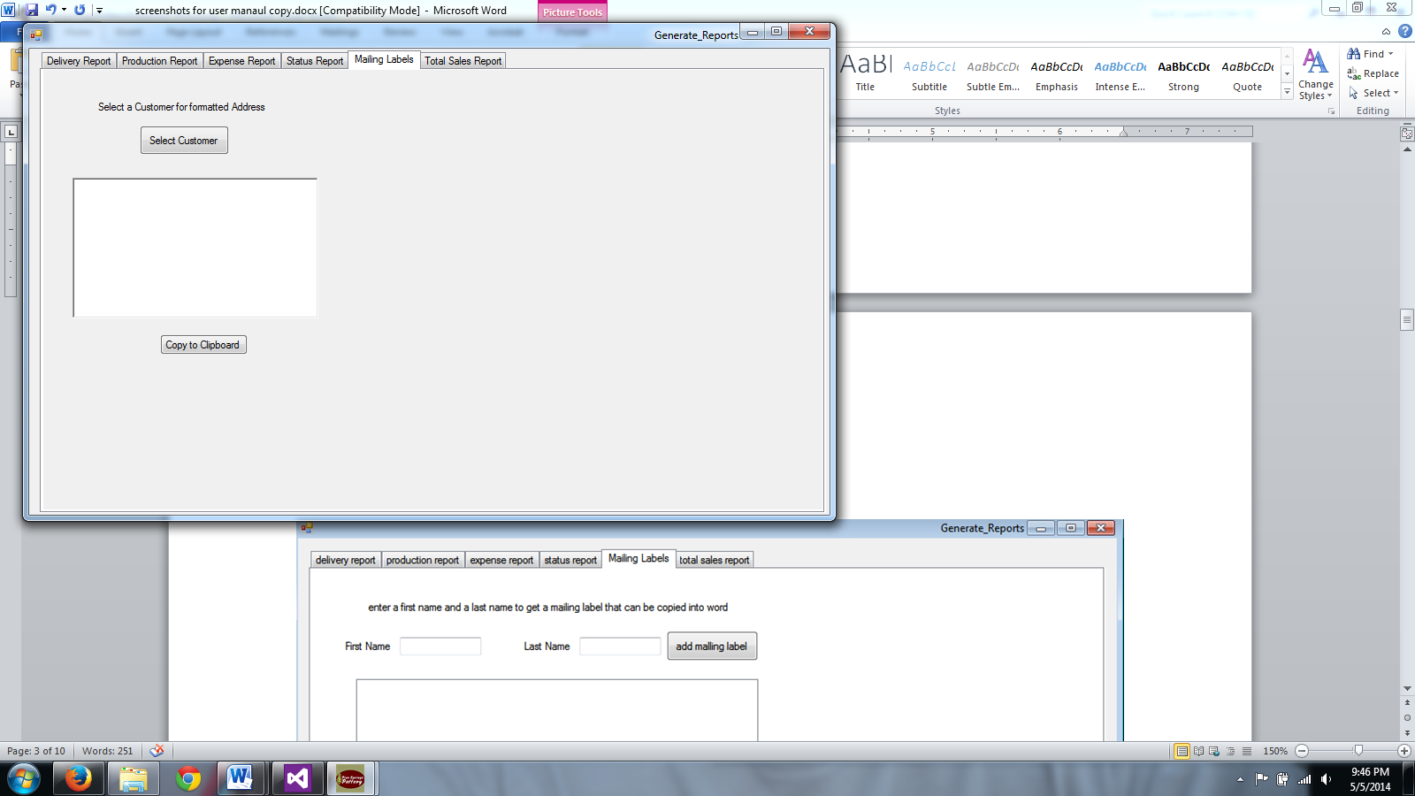

Then, click Copy to Clipboard. You can now paste the formatted text into a word document.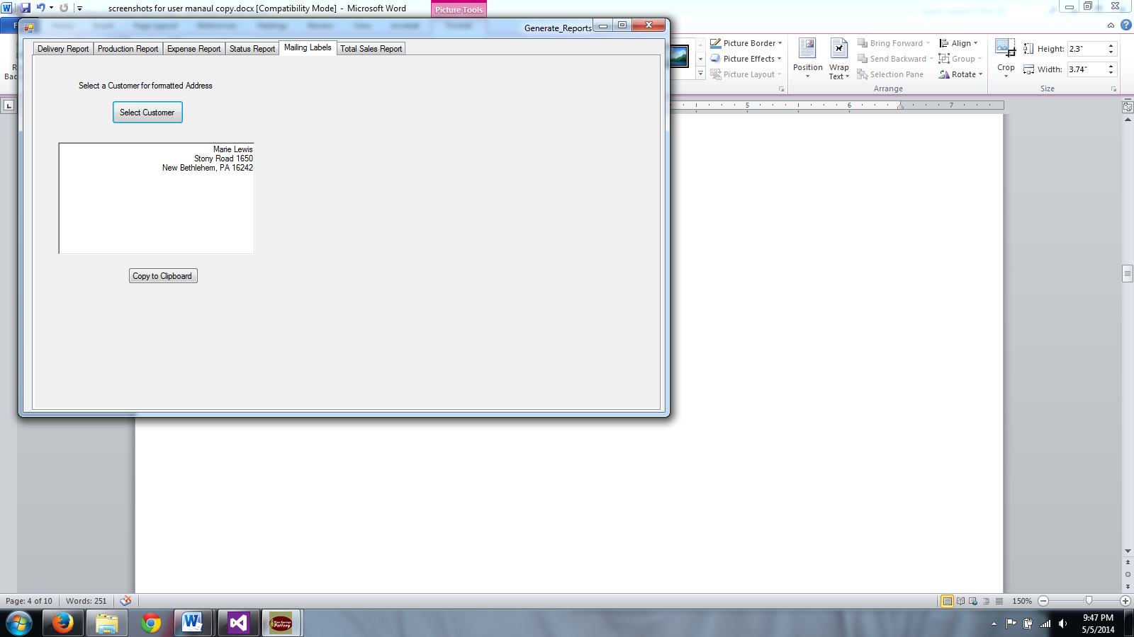

Below is a screenshot of the Total Sales Report. Select the start date and end date from the calendar tool. Then, click Display report to view the report.

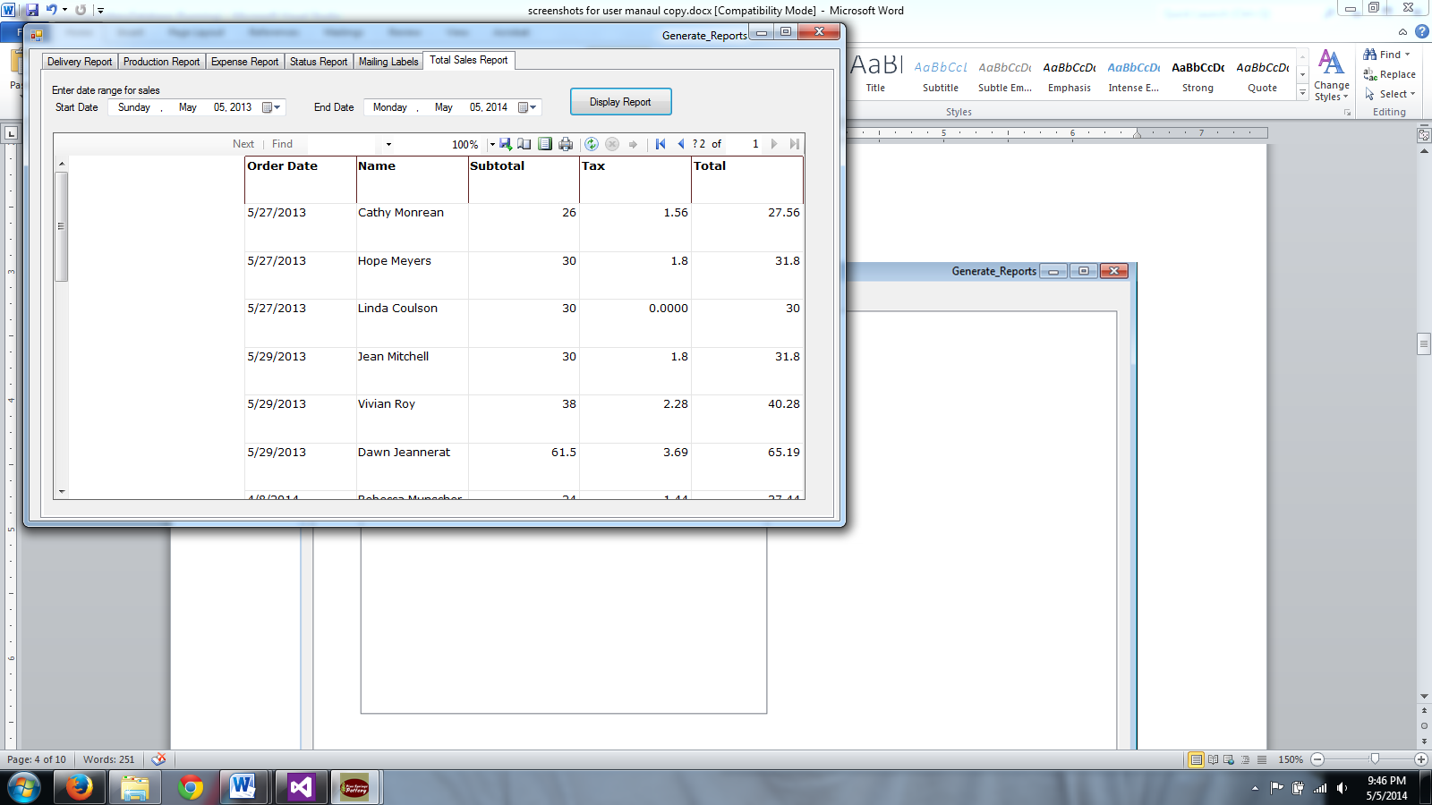

# Installation

1. Place the Installation CD into CD/DVD drive.
2. Run Setup.exe.

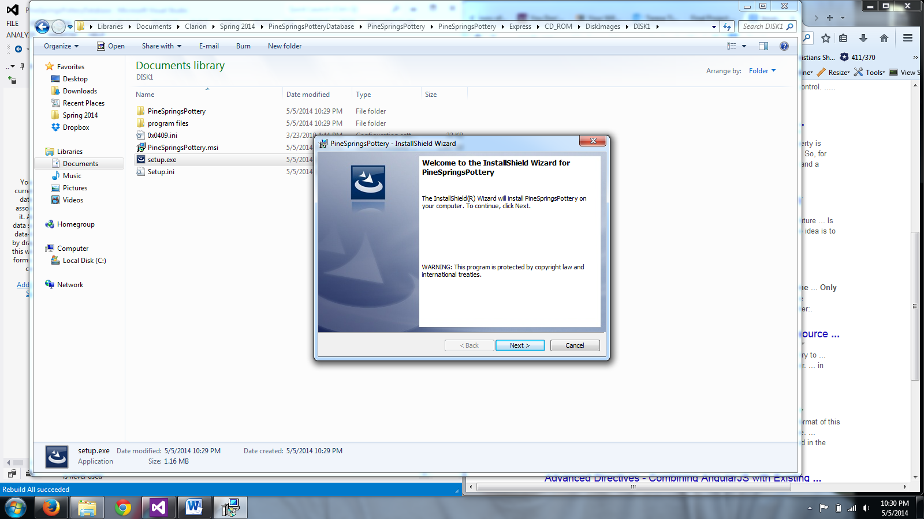

1. Click Next.

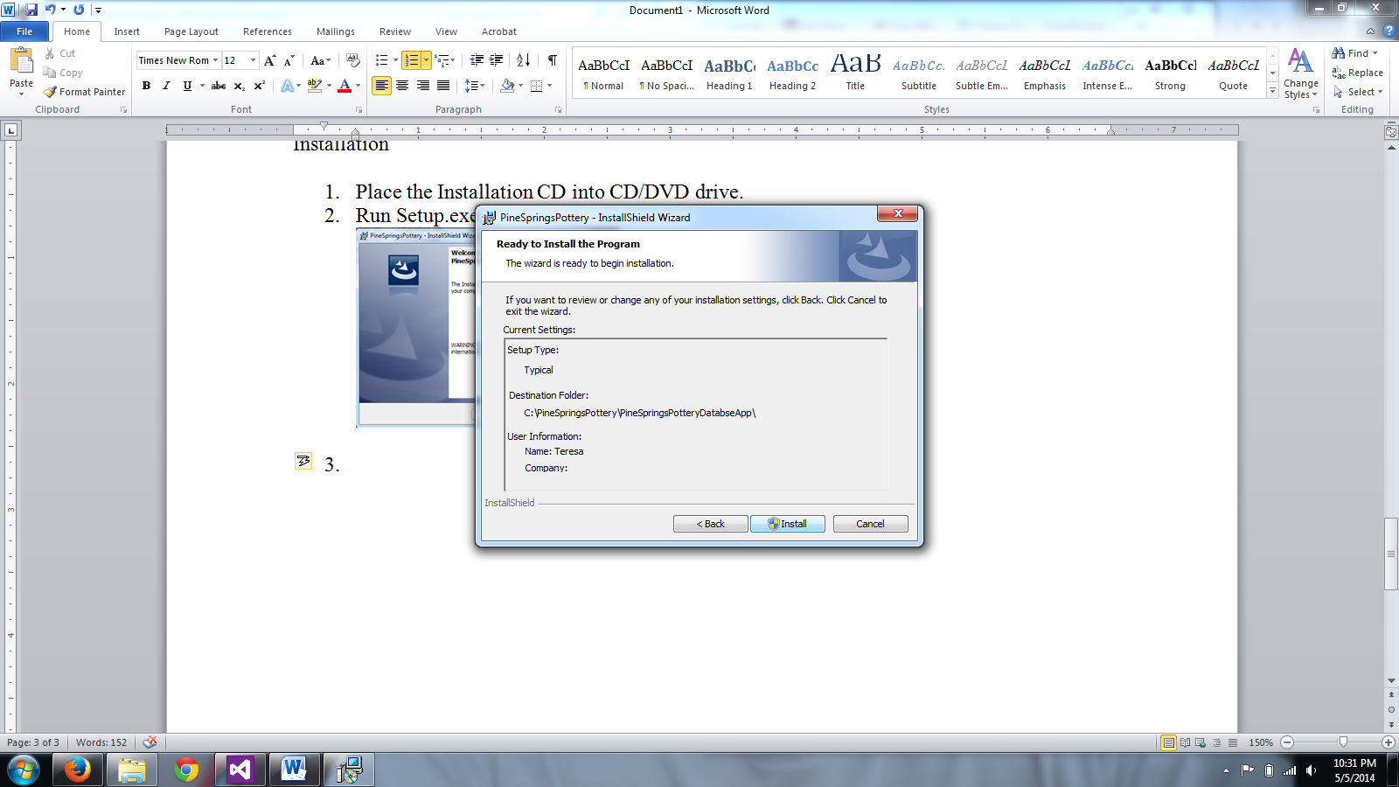

1. Click Install and wait for the program to be installed. If a window pops up asking for permission, click Yes.

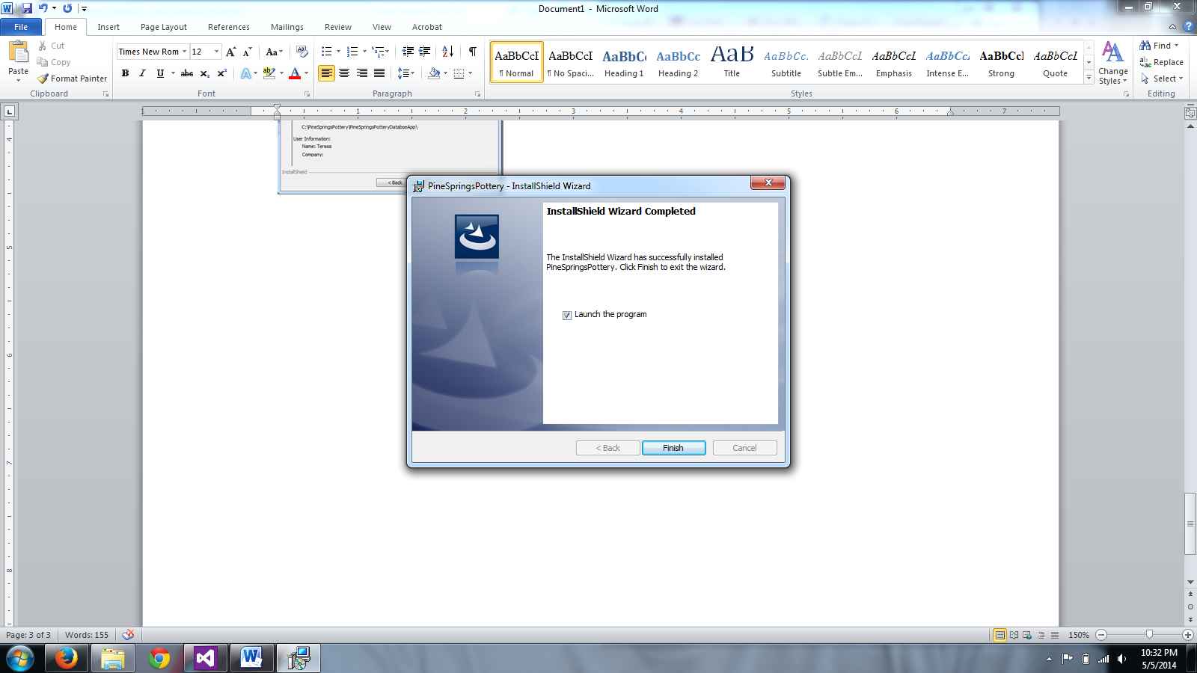

1. Click Finish.
2. A shortcut to the program will be located on your desktop.
3. The installation folder should be “C:\PineSpringsPottery\PineSpringsPotteryDatabseApp”
   1. This is where the PineSpringsPottery.accdb should be restored if needed.
   2. This folder also contains the label templates and Cellica forms.

# Making Address Labels from Access (Avery 5160 – Full sheets)

## Guests for a Show

1. Open PineSpringsPottry.accdb
2. Double click [“ShowDate Guestlist Address Labels – 5160”]

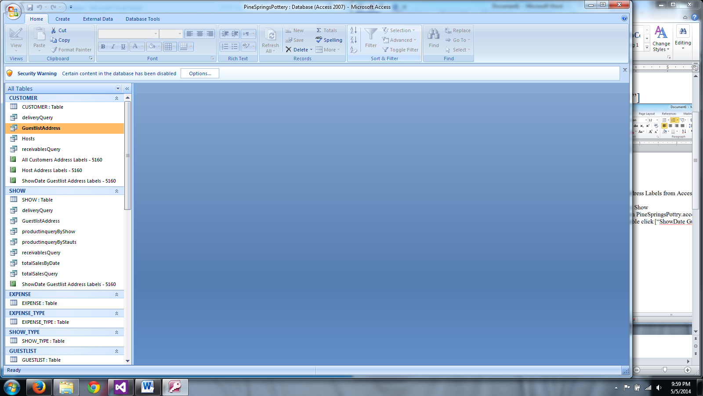

1. Enter the date of the show (M/DD/YYYY) and click [OK]

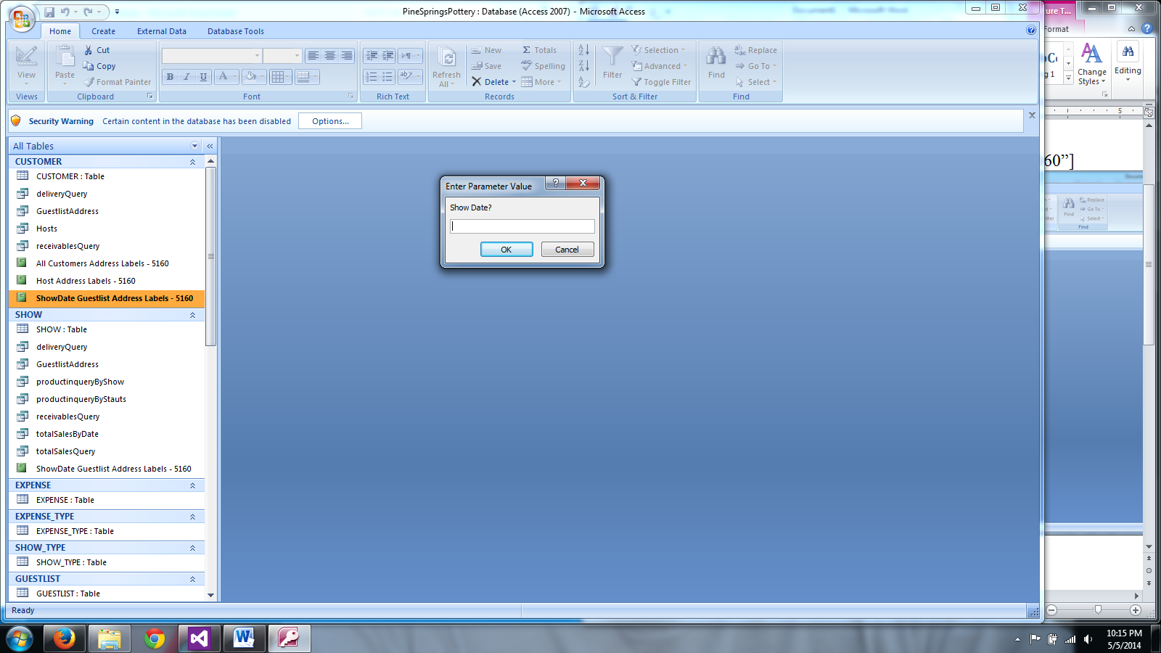

1. This will bring up a list of guests and addresses associated with the show.

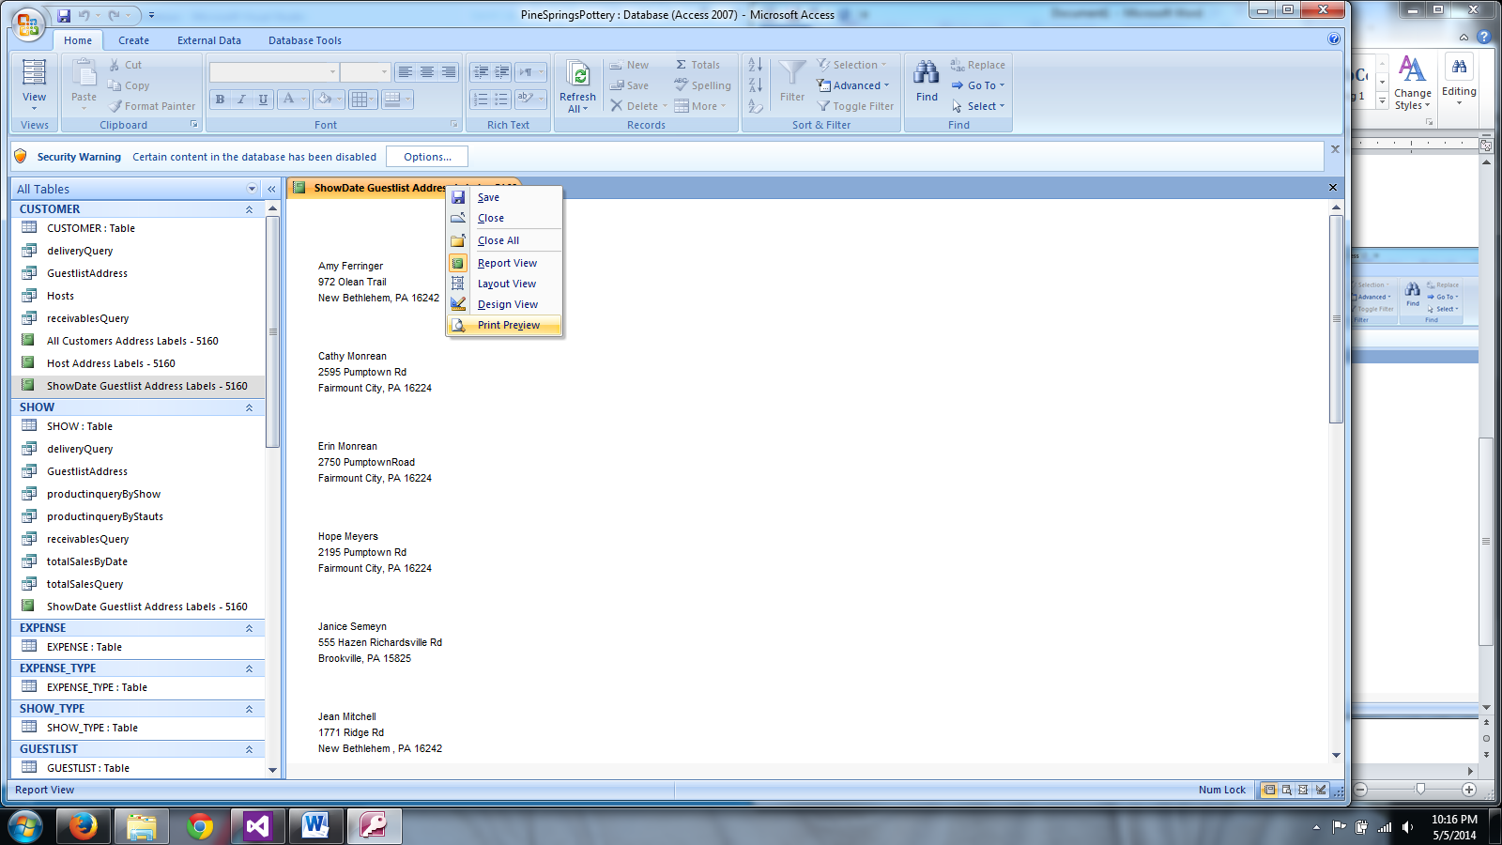

1. Right click on the tab [“ShowDate Guestlist Address Labels – 5160”] and select “Print Preview” to get the addresses formatted to print on Avery 5160.

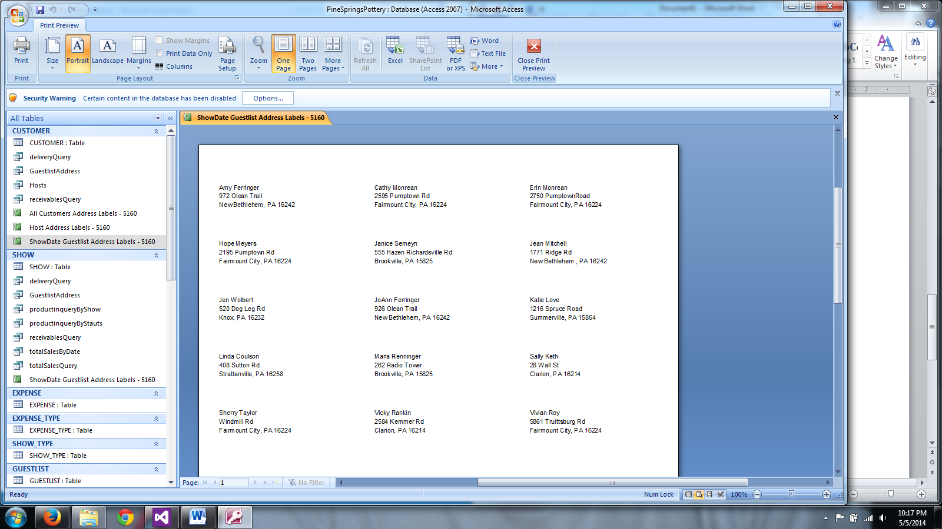

## All Customers

1. Repeat process above with “All Customers Address Labels – 5160”.
2. There will be no “Show Date” input.

## Hosts

1. Repeat process above with “Host Address Labels – 5160”.
2. There will be no “Show Date” input.

This solution will not allow for partial sheets and is only formatted for Avery 5160. To make custom address label sheets, open the correct template from “C:\PineSpringsPottery\PineSpringsPotteryDatabseApp\Labels”. Then copy the addresses from the Generate Reports\Mailing Labels section of the main program.

# Cellica (Desktop)

## Check Status of Syncing

To check if the forms and profiles from Cellica have successfully synced, click on the Check Status button on the forms or profiles screen and the screen will update the status next to the form or profile.

## Troubleshooting

If there is a problem with syncing between the iPad and PC:

1. Start by clicking Check status on the profiles or forms screen and then trying to sync from the iPad.
2. If step 1 does not work, navigate to the preferences screen and click stop synchronization and after it has stopped, click start synchronization.

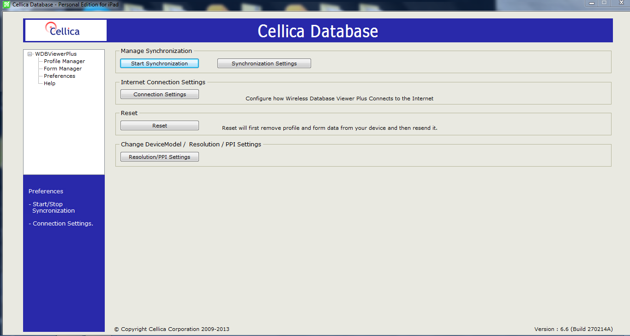

1. If neither step 1 or 2 work, you can contact Cellica in one of three ways:
   1. Go to <http://cellica.kayako.com/> to search for an answer
   2. Go to <http://cellica.kayako.com/Tickets/Submit> to submit a ticket to Cellica support and they will e-mail you
   3. Navigate to the help screen in Cellica and choose a link

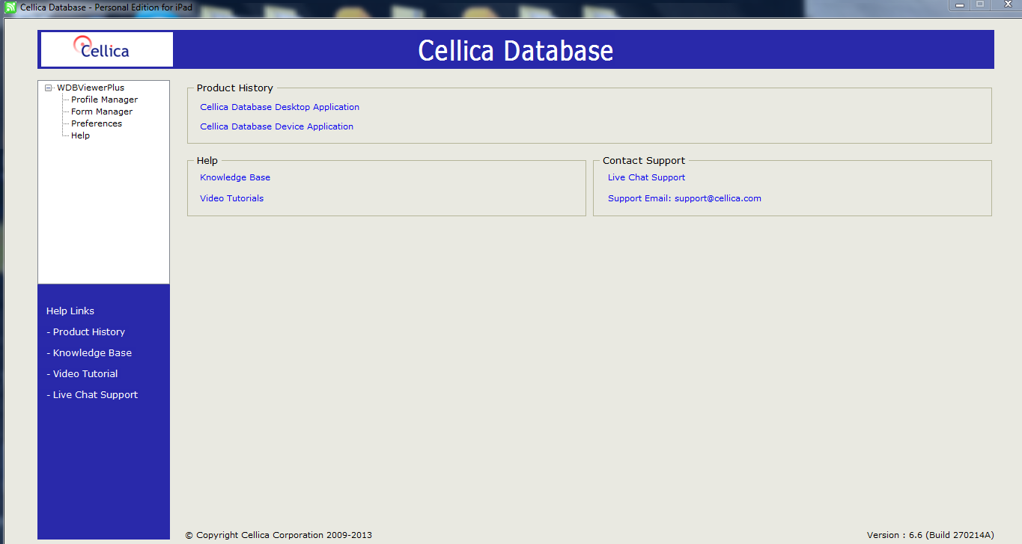

# Re-installing Cellica Desktop

## Downloading

To reinstall the Desktop end of Cellica:

1. From the iPad select Send Desktop Download Link to e-mail a download link to yourself so your iPad and PC are connected

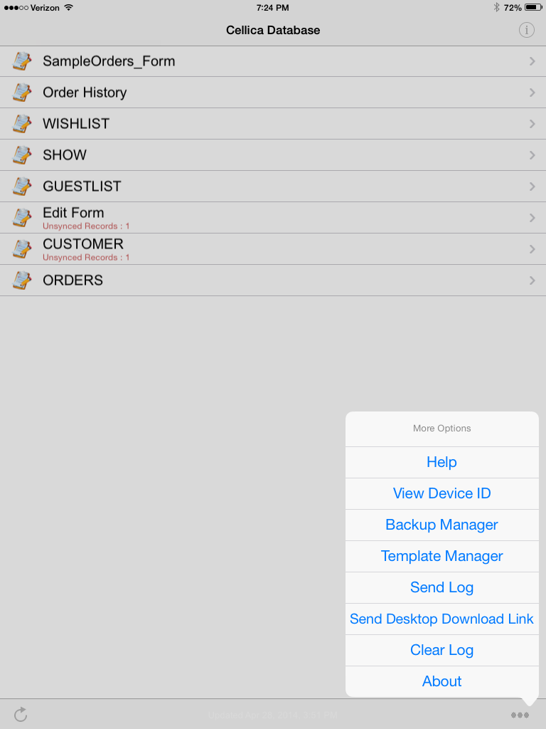

1. Click the link in the e-mail and Cellica will start to download
2. After Cellica has downloaded enter the license number you were originally given or if you do not have the number anymore contact Cellica Support (http://cellica.kayako.com/Tickets/Submit)

## Adding Profiles

It is necessary to add profiles before adding the forms. Start by

1. Clicking add on the profile screen

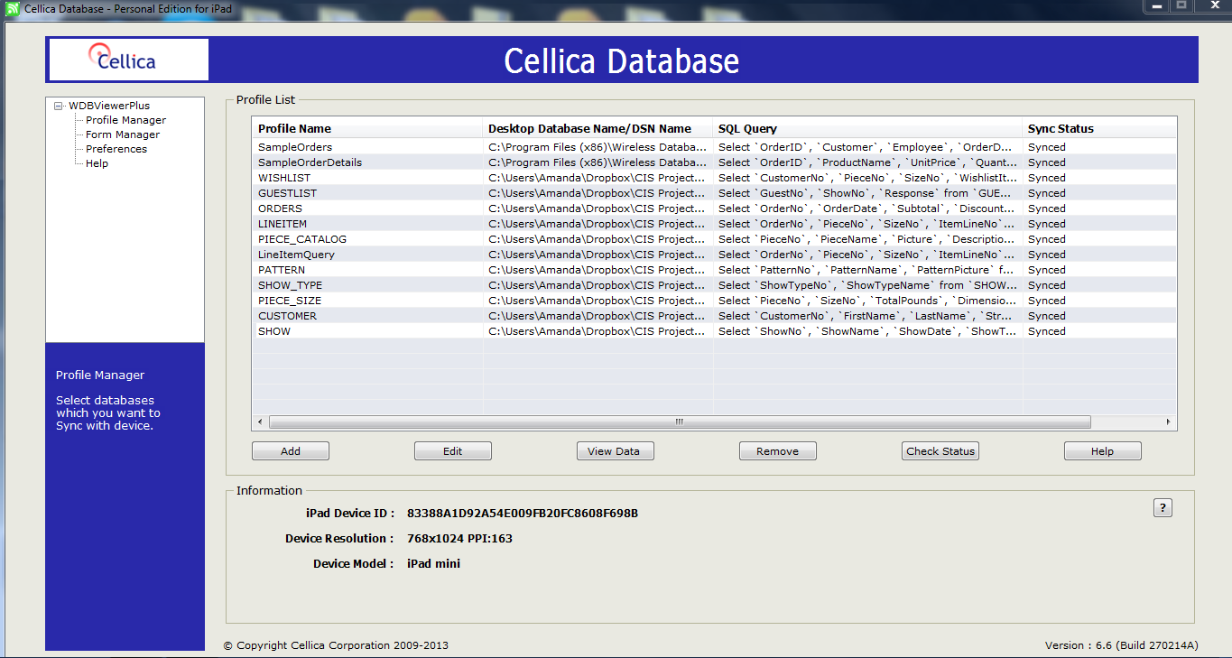

Which will open the following screen:

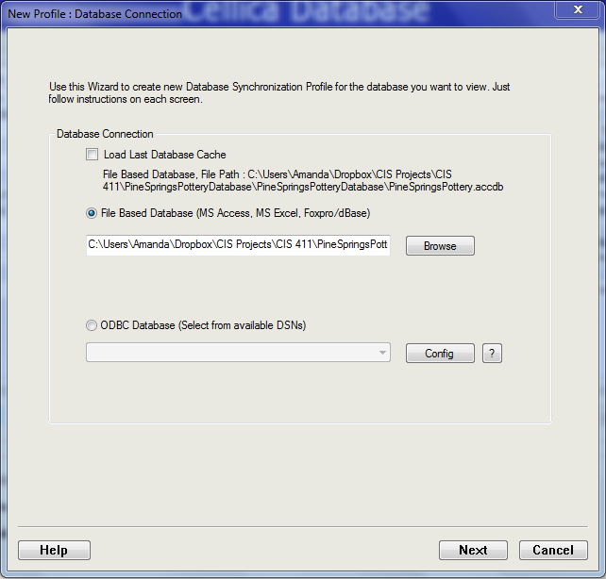

When the screen opens the first time there will be an option to load last database cache.

1. Click browse
2. Navigate to the database saved in the computer files (like you would to back-up the database)
3. Click Next
4. Select a table (Customer is selected in the table below) then click Apply

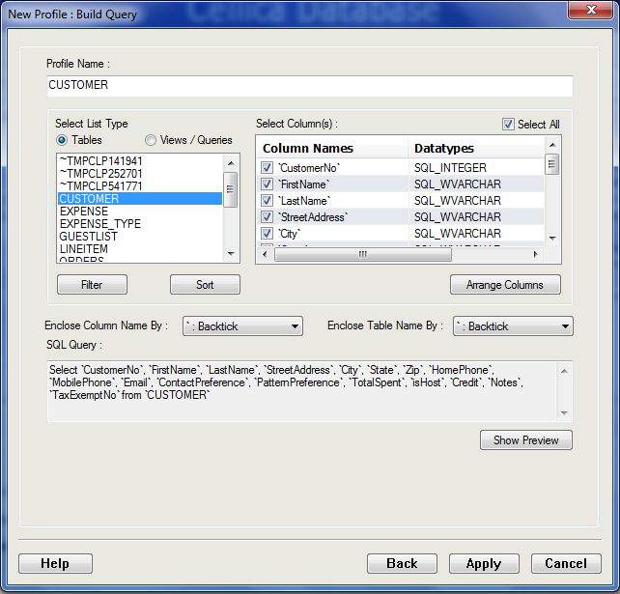

1. Repeat steps 1-6 with the tables GUESTLIST, WISHLIST, LINEITEM, ORDERS, SHOW, PIECE_CATALOG, PATTERN, SHOW_TYPE, and PIECE_SIZE
2. Next you can move on to importing forms. Click Form Manager on the left of the screen

## Importing Forms

1. Your screen should now look like this
2. Click add
3. Click Import Form
4. Navigate to where the forms (.fm files) are saved (Same place as the database)
5. Select one of the forms (start with Wishlist)
6. Click Apply
7. Repeat steps 2-6 (recommended order is: customer (link go to orders to wishlist), show (link go to host info button to customer form by customer number), order(link to customer and show forms), and then guestlist (link to show))

Link forms (wishlist does not link to anything, also use wishlist when creating customer form and then after adding order form go back and do step i.

* 1. Click Go To button (Go to customer info, go to orders, etc…)
  2. Click … button next to form selection

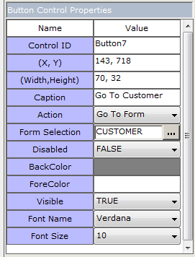

* 1. Click desired form in the drop down menu
     1. For Customer form select ORDERS, click add, click add, change first drop down to customerNo and third drop down to customerNo. Click ok until you are back to the form (three ok buttons). Click Apply.
     2. For Show form select CUSTOMERS, click add, click add, change first drop down to hostNo and third drop down to customerNo. Click ok until you are back to the form (three ok buttons). Click Apply.
     3. For Guestlist form select SHOWS (Go To Show Info) and CUSTOMERS (Go To Customer Info, click add, click add, change first drop down to ShowNo(GuestNo) and third drop down to ShowNo(customerNo). Click ok until you are back to the form (three ok buttons). Click Apply after doing this for both buttons.
     4. For Orders form select SHOWS (and CUSTOMERS), click add, click add, change first drop down to ShowNo(CustomerNo) and third drop down to ShowNo(customerNo). Click ok until you are back to the form (three ok buttons). Click Apply after doing this for both buttons.

First Click Add

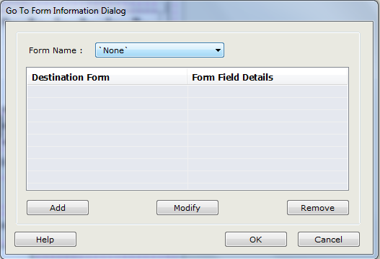

Second Click Add

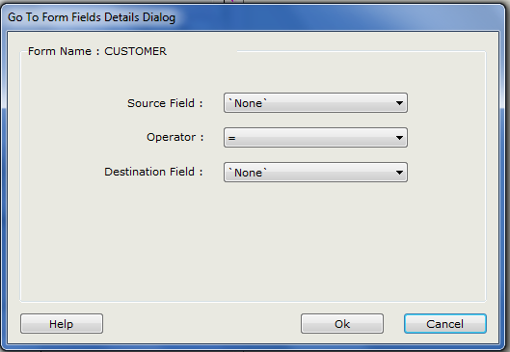

1. Some forms have subforms so they require a few extra steps
   1. Open ORDERS form (this has 2 subforms both will follow the same steps)
   2. Click on the subform (the scrollbar)

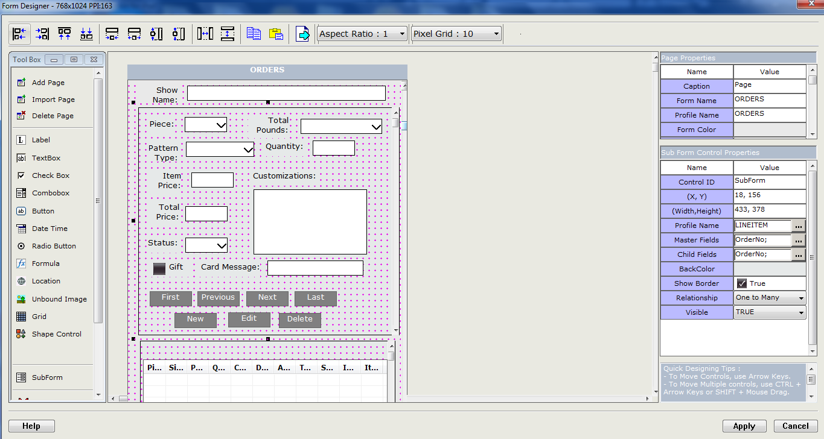

* 1. Click on the … button next to the profile name
  2. Select LINEITEM
  3. Click ok
  4. Click … button next to Master Field and change the drop downs (both) to OrderNo
  5. Click ok
  6. Click Apply
  7. Open Guestlist form
  8. Click on the subform
  9. Click profile name
  10. Select guestlist
  11. Click ok
  12. Click master field and change the drop downs to showNo
  13. Click Apply
  14. Open Wishlist
  15. Click the subform
  16. Click profile name
  17. Select Wishlist
  18. Click ok
  19. Click Master Field and change drop downs to customerNo
  20. Click ok
  21. Click Apply

# Cellica (iPad)

After opening Cellica for the first time on your iPad, your screen will open up to a menu screen with a list of the forms available (as shown below).

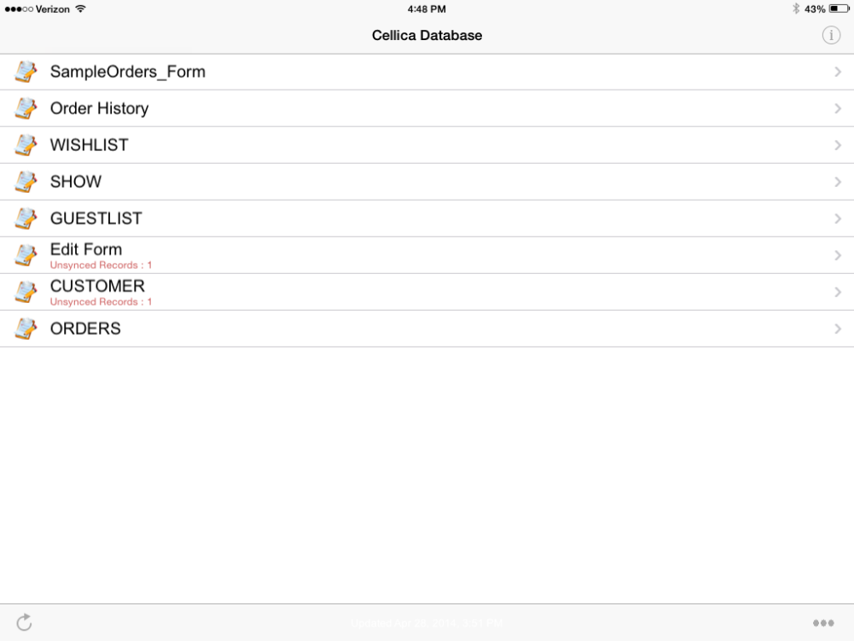

On this screen, you can view options in the lower right corner. These options are important if you need to contact Cellica for help with a problem. Cellica may ask for your Device ID (View Device ID) or Logs (Send Log). If you need to re-download Cellica on your desktop, you can send a link to your email by clicking “Send Desktop Download Link”.

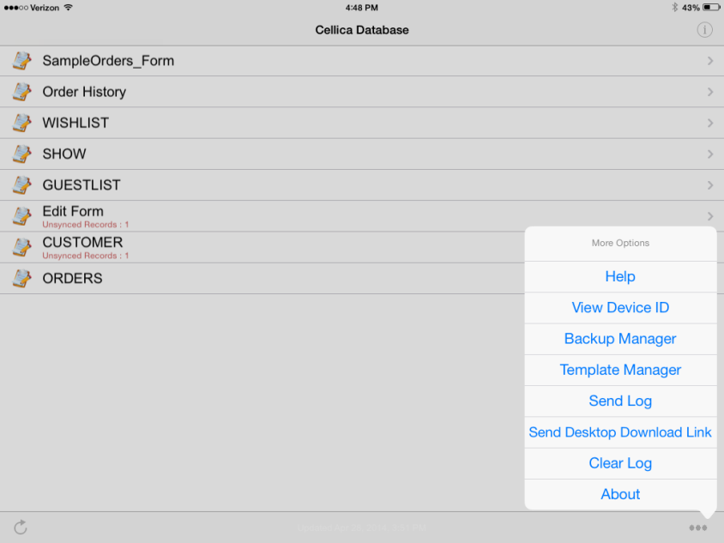

In the top right corner of the menu screen, there is an information button if you click on that you will see a Preferences screen (shown below). Make sure that the “View” is set to “Forms” and “Syncing Mode” is set to “Auto”.

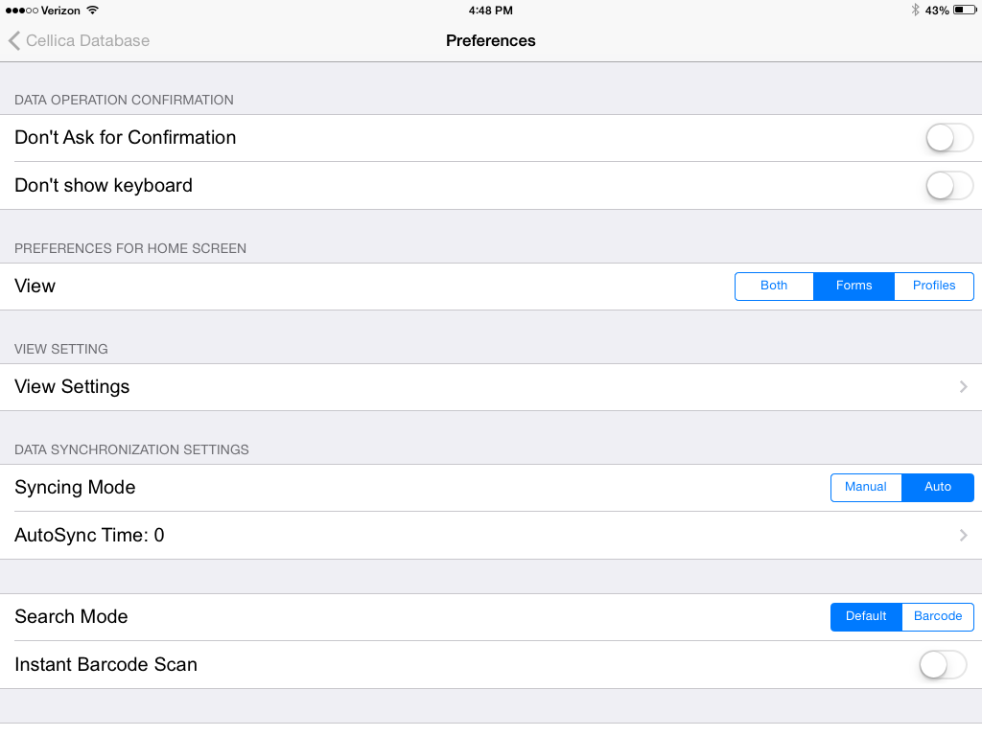

If you would like to set a password for Cellica, “Preferences” “Password” is where you would be able to set it up.

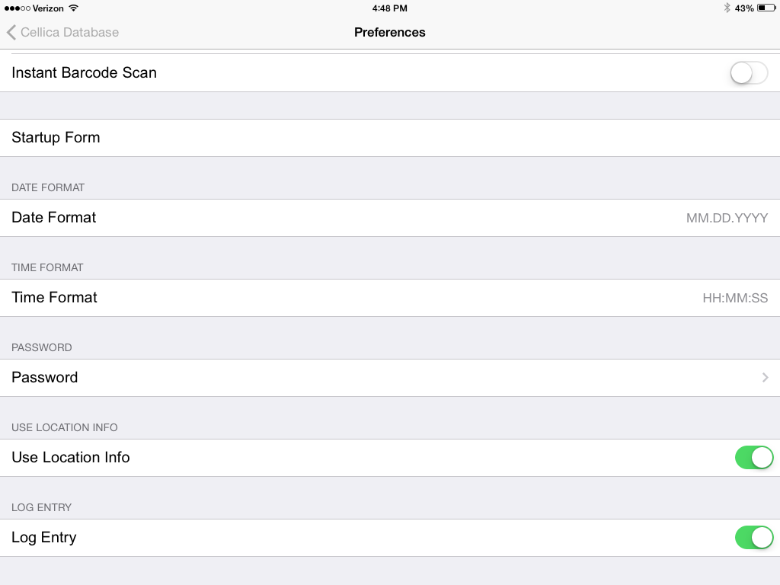

On the Menu Screen, on the lower left corner is the sync button, once you click that it will send any updated information to your desktop and receive any new information from the desktop. This does not always work.

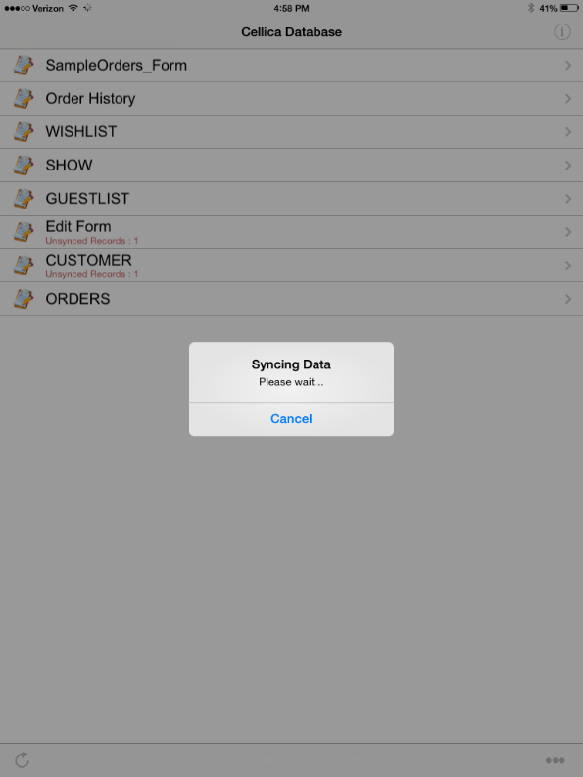

The CUSTOMER form allows you to enter/view customer information. You can navigate using the “First”, “Previous”, “Next”, and “Last” buttons, add a new customer (“New”), edit a customer (“Edit”), find a customer (“Search”), go to the orders form, or sync.

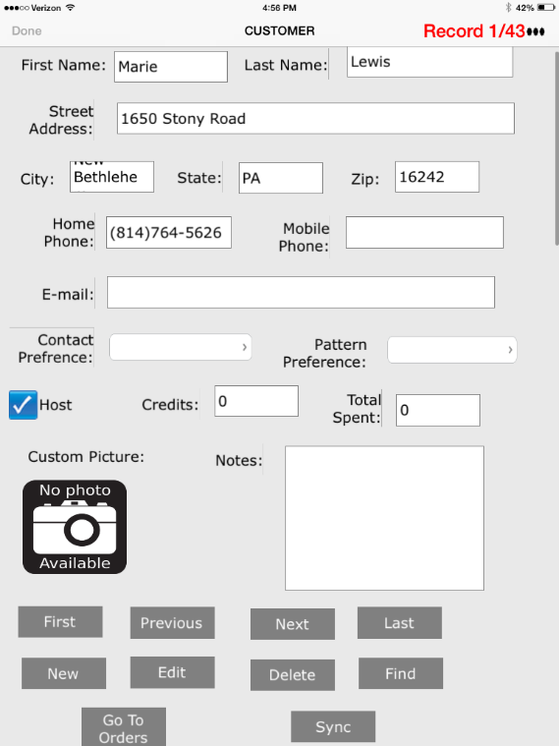

The WISHLIST form allows you to view a customer’s wish list, edit the wish list, or navigate the wish lists.

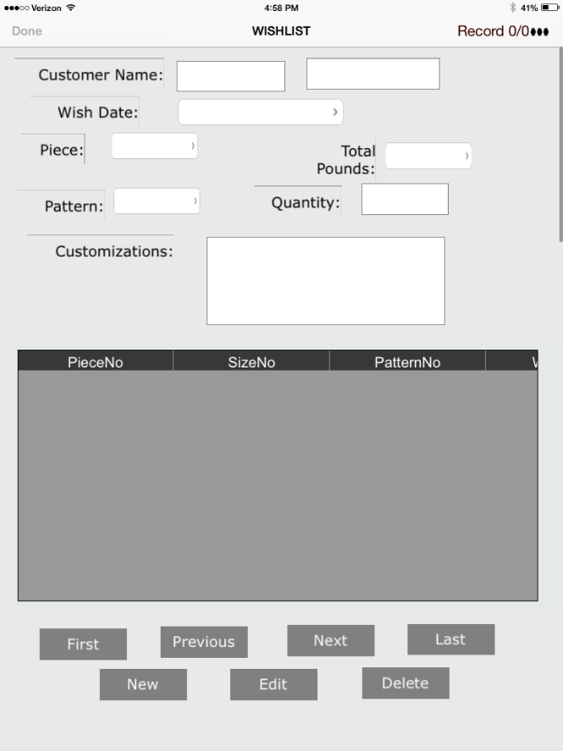

The SHOW form allows you to navigate the shows, enter a new show or edit a show, go to the host’s customer information form, or take a picture (“Capture”) of the screen and email the screen shoot.

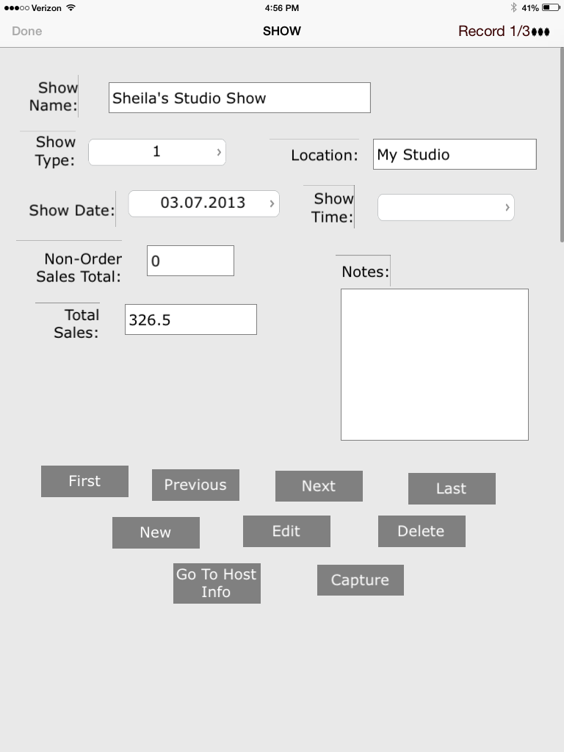

The GUESTLIST allows you to navigate between the show guest list, add a new guest list, edit a guest list, or view customer or show information.

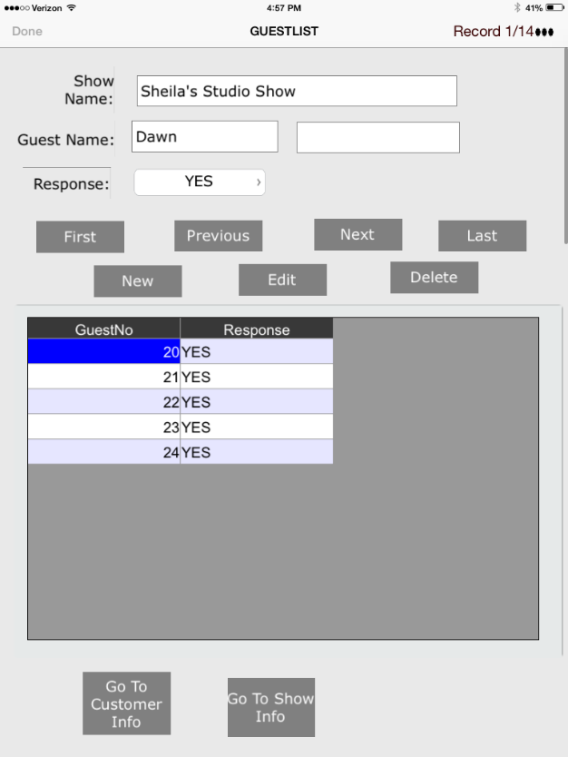

The ORDERS form is long so you have to be careful when scrolling the screen. On the orders screen, you can navigate the orders and pieces in the order. You can also view the customer information or show information that is connected to the order.

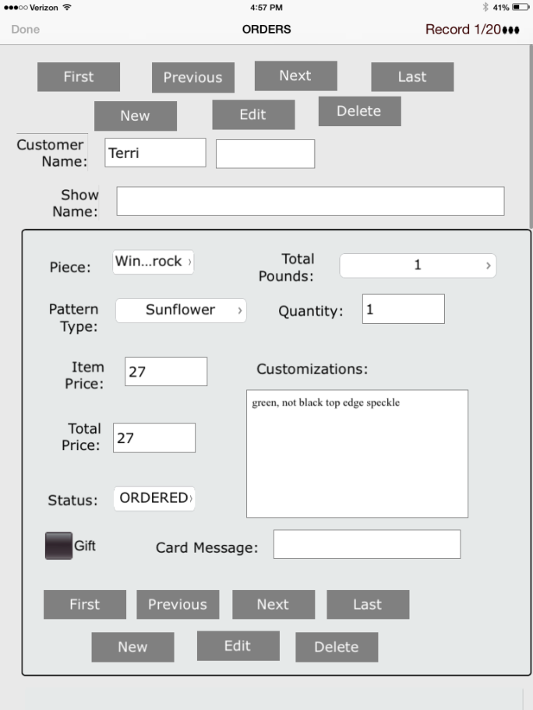

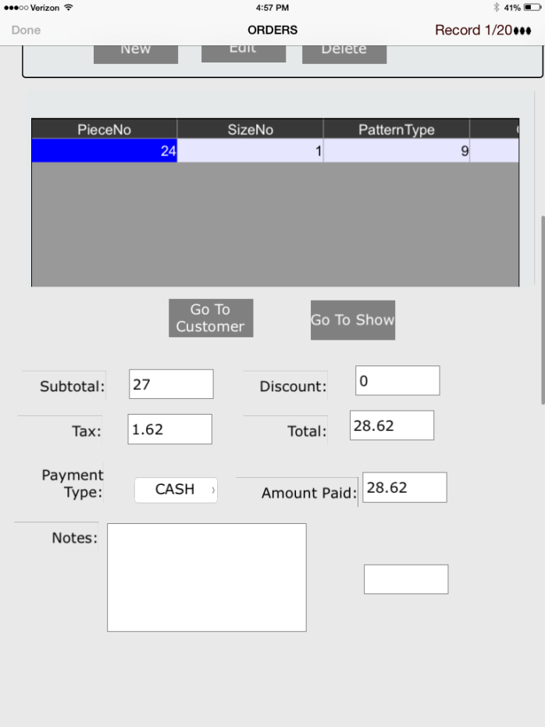

# Downloading the Cellica App for the iPad

In the App Store, search for “Cellica Database for iPad”. Select Cellica Database for iPad (Database Viewer Plus).

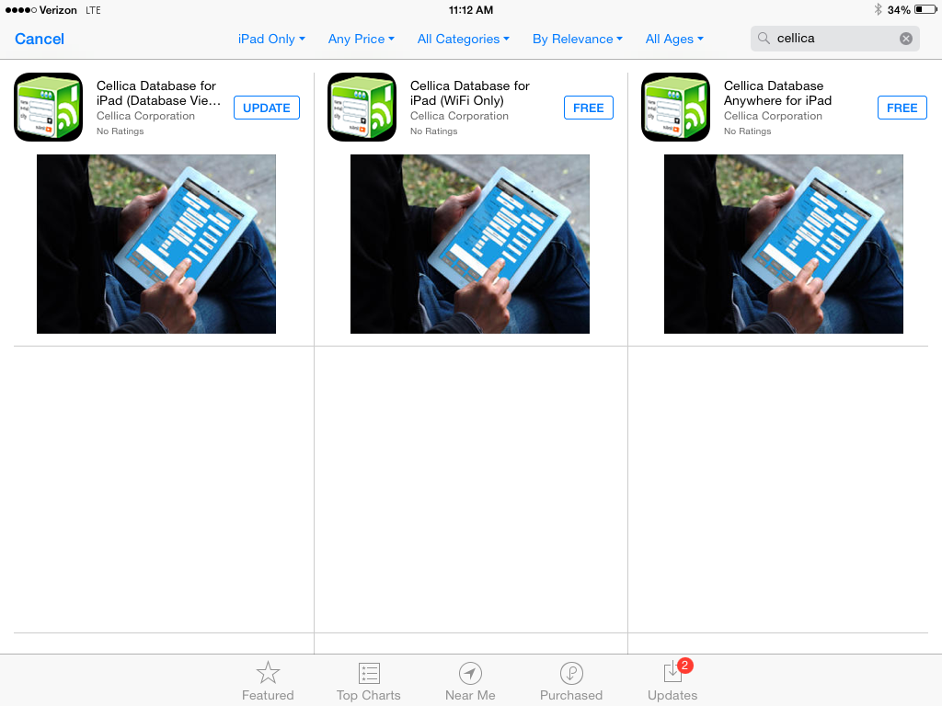

Click [Install] to install Cellica on to your iPad.

